**MẠNG XÃ HỘI GJOBS**

**TÀI LIỆU PHÂN TÍCH VÀ ĐẶC TẢ  
YÊU** **CẦU PHẦN MỀM**

**Tp HCM, 04/2015**

**BẢNG GHI NHẬN THAY ĐỔI TÀI LIỆU**

| **Ngày thay đổi** | **Vị trí thay đổi** | **Lý do** | **Nguồn gốc** | **Phiên bản cũ** | **Mô tả thay đổi** | **Phiên bản mới** |
| --- | --- | --- | --- | --- | --- | --- |
|  |  |  |  |  |  |  |
|  |  |  |  |  |  |  |
|  |  |  |  |  |  |  |

# Sơ lược, đặc điểm nổi bật của Elgg so với việc xây dựng từ đầu, các engine khác

## Sơ lược

Elgg là một mã nguồn mở mạng xã, cung cấp một framework mạnh mẽ để xây dựng tất cả các loại môi trường xã hội, từ một mạng xã hội giáo dục cho các trường đại học, trường học hoặc đoàn thể tập thể hoặc một nền tảng hợp tác nội bộ cho tổ chức của bạn thông qua một công cụ để xây dựng kênh thông tin truyền thông cho công ty của bạn và khách hàng của mình.

Elgg có tất cả các tính năng bạn mong muốn từ một ứng dụng web xã hội. Nó có thể viết blog, chia sẻ tập tin, social bookmarking, microblogging, activity streams, groups, "friending", user profiles, và danh sách liên hệ. Tuy nhiên, Elgg không chỉ nhiều hơn một ứng dụng web thông thường. Nó cũng có thể được sử dụng như một framework để tạo ra các trang xã hội. Các nhà phát triển xây dựng các trang mạng xã hội đầy ấn tượng hàng đầu với Elgg qua các API mạnh mẽ của nó. Họ đang sử dụng nó để phát triển thêm các chức năng xã hội với các trang web hiện tại và tích hợp nó với các ứng dụng web phổ biến khác.

## Đặc điểm nổi bật

### So với xây dựng từ đầu

Elgg là một nền tảng cung cấp các khối xây dựng để tạo ra các trang mạng xã hội to lớn. Trong khi bạn có thể cài đặt Elgg và lập tức bắt đầu sử dụng nó như là một trang mạng xã hội, hầu hết các bạn sẽ muốn tùy chỉnh nó. Với những người không phải là nhà phát triển có thể tải về các plugin để thay đổi giao diện và cảm nhận hoặc thêm tính năng mới. Đối với các phát triển, gần như tất cả các phần của Elgg có thể được tùy chỉnh bằng cách viết bổ sung mới.

Cấu hình máy chủ được đề nghị chạy được Elgg gọi là một LAMP stack. Đây là viết tắt của Linux, Apache, MySQL, và PHP là ngôn ngữ được sử dụng. Elgg cũng có thể chạy trên nhiều hệ điều hành như Windows hay Mac OS X và các máy chủ web khác.

### So với các engine khác

* Data Model mạnh mẽ

Elgg cung cấp một mô hình dữ liệu mạnh mẽ làm cho việc tạo ra các thực thể khác nhau đơn giản, nhưng linh hoạt.

* Hoạt động Streams
* Các hoạt động Streams hạt API đảm bảo plugins của bạn có thể đẩy các nội dung cần thiết đển người dùng của bạn.
* Plugin API

Sử dụng mạnh mẽ Plugin API Elgg để xây dựng và bổ sung thêm các tính năng cần thiết của bạn.

* Quản lý tài khoản

Elgg xử lý quản lý và mối quan hệ yêu cầu sử dụng của bạn.

* Điều khiển truy cập

Tất cả các đối tượng trong Elgg có thể có một mức độ kiểm soát truy cập ứng dụng làm cho quyền truy nhập có thể.

* Dịch vụ Web API

Đưa ra chức năng thông qua các API REST bằng cách xây dựng một plugin và sau đó publish các API cho các nhà phát triển khác để xây dựng khách hàng hoặc cung cấp riêng của bạn.

# Các license của elgg

Elgg là framework miễn phí. Nó là phần mềm mã nguồn mở nên sử dụng giấy phép mã nguồn mở với license GNU phiên bản 2 và license MIT.

## Giới thiệu về license GNU

Giấy phép Công cộng GNU (GNU General Public License, viết tắt GNU GPL hay chỉ GPL) là giấy phép phần mềm tự do phổ biến nhất, mới đầu do Richard Stallman viết cho dự án GNU.[1] Phiên bản hiện hành của giấy phép này là phiên bản 3 năm 2007, phiên bản được sử dụng nhiều nhất hiện nay là phiên bản 2 năm 1991. Giấy phép Công cộng GNU Hạn chế (LGPL) là giấy phép sửa đổi của GPL, được sử dụng cho một số thư viện phần mềm.

Giấy phép GPL phiên bản 2 gồm 12 điều khoản.

GPLv2, gần giống như bất kỳ giấy phép nào, trao các quyền theo các điều khoản nhất định. Chúng được liệt kê ngắn gọn ở đây. Một phần mềm được cấp giấy phép GPL v2 có thể:

* Sao chép và phân phối mã nguồn chưa được sửa đổi của chương trình (Phần 1)
* Sửa đổi mã nguồn của chương trình và phân phối nguồn được sửa đổi (Phần 2)
* Phân phối các phiên bản được biên dịch của chương trình, cả được sửa đổi và không được sửa đổi (Phần 3) miễn là:
* Tất cả các bản sao (được sửa đổi hay không) mang một lưu ý bản quyền và sự loại trừ đảm bảo (Phần 1 và 2)
* Tất cả các bản sao được phân phối theo GPLv2 (Phần 2)
* Tất cả các phiên bản được biên dịch của chương trình được đi kèm với mã nguồn tương ứng, hoặc một sự mời chào có thể sống được để làm cho mã nguồn là sẵn sàng (Phần 3)

## Giới thiệu về license MIT

MIT là một giấy phép phần mềm tự do được phát hành bởi Học viện Công nghệ Massachusetts (Massachusetts Institute of Technology – MIT), được hội đồng MIT X sử dụng.

Theo Tổ chức phần mềm tự do, giấy phép MIT nên được gọi chính xác hơn là giấy phép X11, do Học viện Massachusetts đã từng dùng nhiều loại giấy phép khác nữa, và do giấy phép này ban đầu được soạn thảo cho X Window System (dự án tạo giao diện đồ họa cho người dùng ở các máy tính kết nối mạng vào năm 1984).

MIT là một giấy phép dạng “permissive”, nghĩa là nó cho phép tái sự dụng các phần mềm độc quyền nhưng với điều kiện giấy phép MIT đã được phân phối kèm phần mềm đó. Giấy phép MIT cũng tương thích GLP, nghĩa là GPL cho phép tổng hợp và tái phân phối các phần mềm sử dụng giấy phép MIT.

– Các quyền lợi của người sử dụng giấy phép vẫn tương tự như ở giấy phép GNU. Tuy nhiên MIT loại bỏ thuộc tính virus khỏi giấy phép, tức không bắt buộc các chương trình sử dụng tài nguyên có dùng giấy phép MIT cũng phải sử dụng giấy phép MIT.

– Giấy phép MIT không bắt buộc phải công khai mã nguồn.

– Người sử dụng phải kèm theo giấy phép MIT vào bản chỉnh sửa của mình, tuy nhiên không bị bắt buộc phải sử dụng giấy phép MIT cho toàn bộ bản đó.

– Giấy phép MIT cũng có thể được chỉnh sửa lại cho phù hợp với thực tế.

Ngoài ra, giấy phép MIT không cấm sử dụng tên của người giữ bản quyền vào mục đích quảng bá, và cũng không bắt buộc phải hiện danh sách tất cả những người từng tham gia thực hiện dự án trong phần About của chương trình.

# Cách cài đặt Elgg

## Yêu cầu:

* MySQL 5+
* PHP 5.4+ với một số extensions sau:
  + GD (for graphics processing)
  + Multibyte String support (for i18n)
  + Proper configuration and ability to send email through an MTA
* Web server hỗi trợ URL rewriting
* Web server
  + Apache server
    - Enable rewrite module
    - Cấu hình Apache chạy PHP
* Hoặc Nginx server
  + PHP-FPM using FastCGI

## Cài đặt môi trường:

### Window

* Trên window chúng ta có thể sử dụng các phần mềm tạo máy chủ Web được tích hợp sẵn Apache, PHP, MySQL… và các công cụ tiện ích khác như Xampp, Appserv…
* Hoặc ta cũng có thể tự cài và cấu hình bằng tay các bộ công cụ này bao gồm: Apache, PHP, MySQL… (Khuyên dùng chúng ta nên tự cài đặt bằng tay sẽ giúp ta chủ động cũng như có thể hiểu sâu hơn.)
* Đây mình sẽ hướng dẫn cấu hình web server bằng tay bao gồm (Apache + PHP + MySQL)
  + Download
    - Apache: <http://www.apachelounge.com/download/> (httpd-2.4.12-win64-VC11.zip)
    - PHP: <http://windows.php.net/download#php-5.6> (VC11 x86 Thread Safe (2015-Feb-19 01:45:25))
    - MySQL: <http://dev.mysql.com/downloads/windows/installer/>
* Sau khi download, giải nén Apache và PHP tiến hành cài đặt
  + Tạo thư mục **../www** chứa source code chương trình

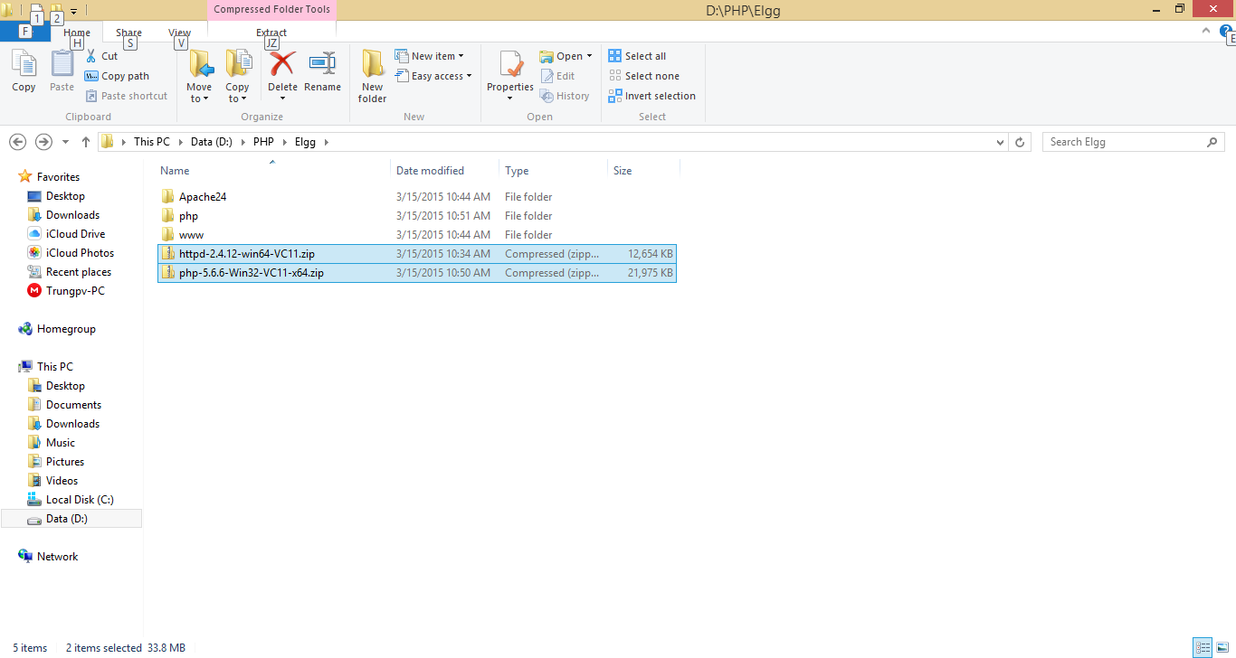

* Cấu hình Apache
  + Edit File httpd.conf

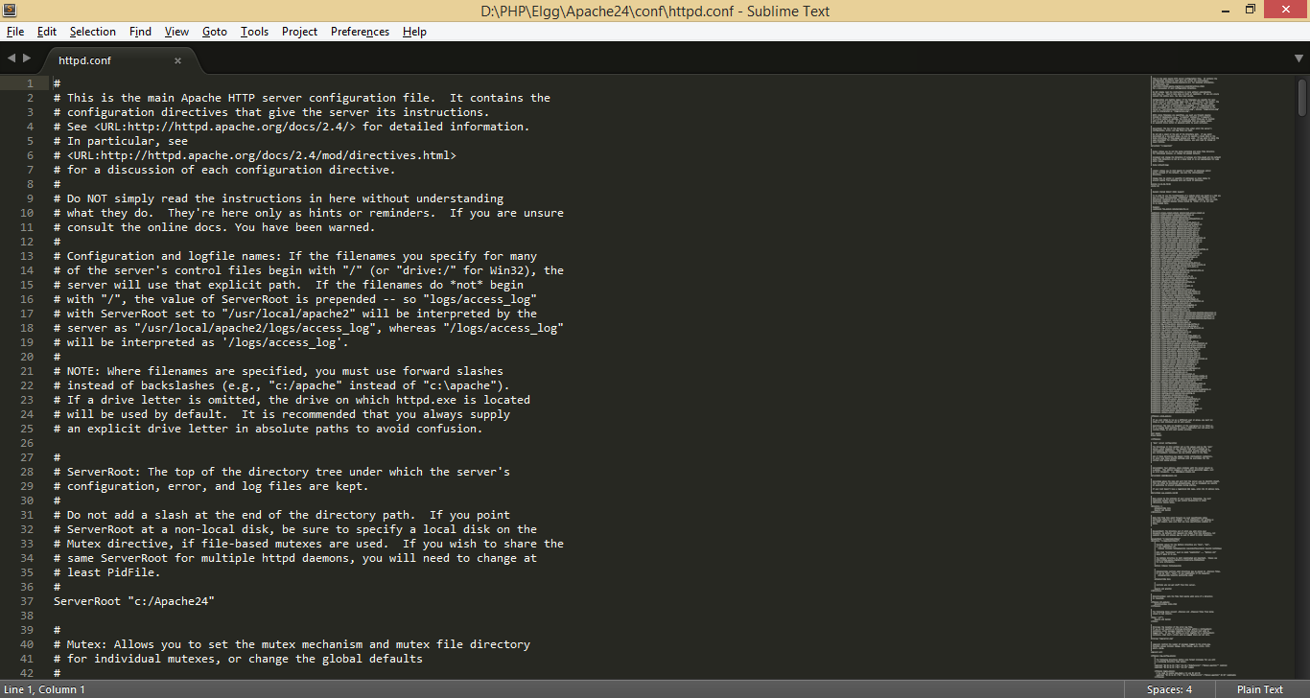

* **ServerRoot "c:/Apache24"** thành **ServerRoot "D:/PHP/Elgg/Apache24"**
* **#ServerName** [www.example.com:80](http://www.example.com:80) thành **ServerName localhost:80** hoặc **ServerName localhost:8081** nếu trùng port
* **Listen 80** thành **Listen 8081** nếu trùng port
* **DocumentRoot "c:/Apache24/htdocs"** và **<Directory "c:/Apache24/htdocs">** thành **DocumentRoot "D:/PHP/Elgg/www"** và **<Directory " D:/PHP/Elgg/www ">**
* Sửa **#LoadModule rewrite_module modules/mod_rewrite.so** thành **LoadModule rewrite_module modules/mod_rewrite.so**
* Tiếp thêm các lệnh sau trong thẻ **<Directory " D:/PHP/Elgg/www ">**:

*<Directory "* ***D:/PHP/Elgg/www****">*

*AllowOverride All*

*Order allow,deny*

*Allow from all*

*Require all gra*nted

</Directory>

* Tiếp đến lưu lại và mở CMD di chuyển đến thư mục cài đặt và chạy lệnh: **httpd.exe -k install**

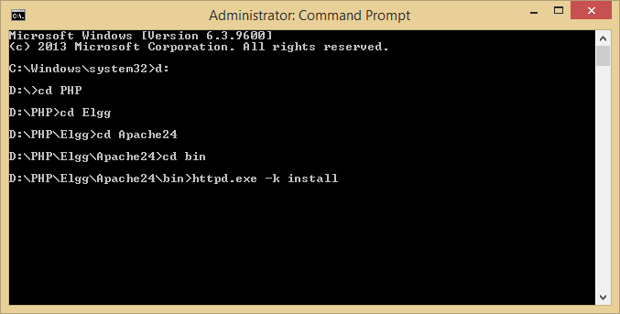

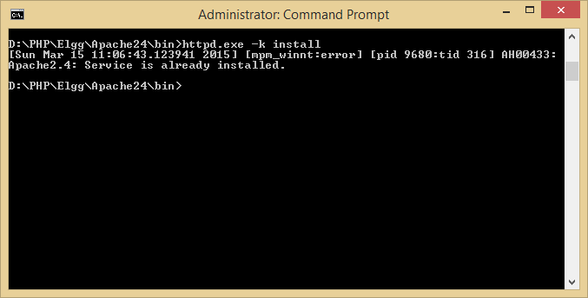

* Khi chạy command thành công ta vào D:\PHP\Elgg\Apache24\bin chạy **ApacheMonitor.exe** và start web server

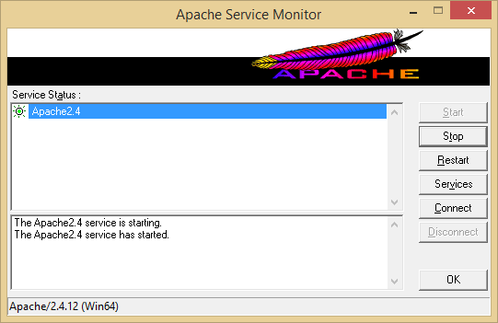

* Tạo 1 file .html trong ../www để kiểm tra

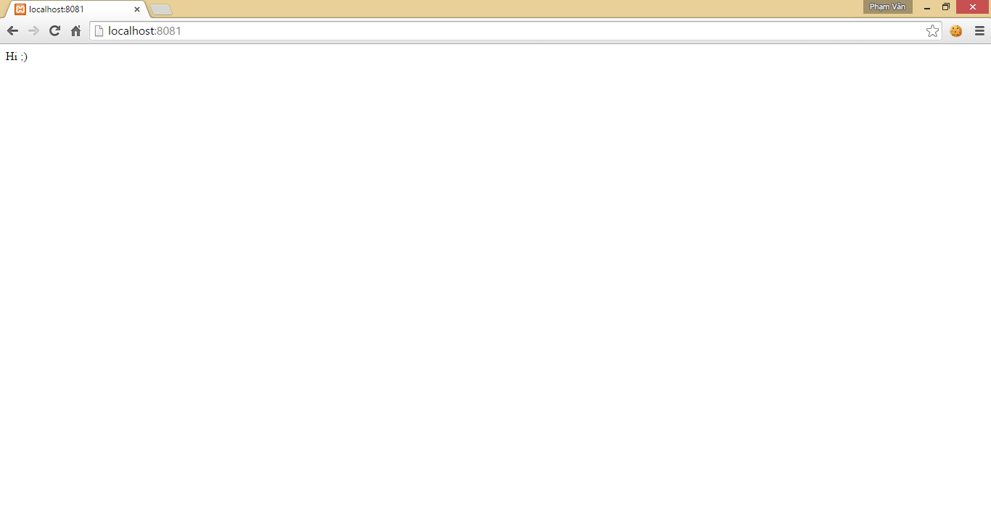

* Cấu hình PHP
  + Sửa file php.ini-development thành php.ini

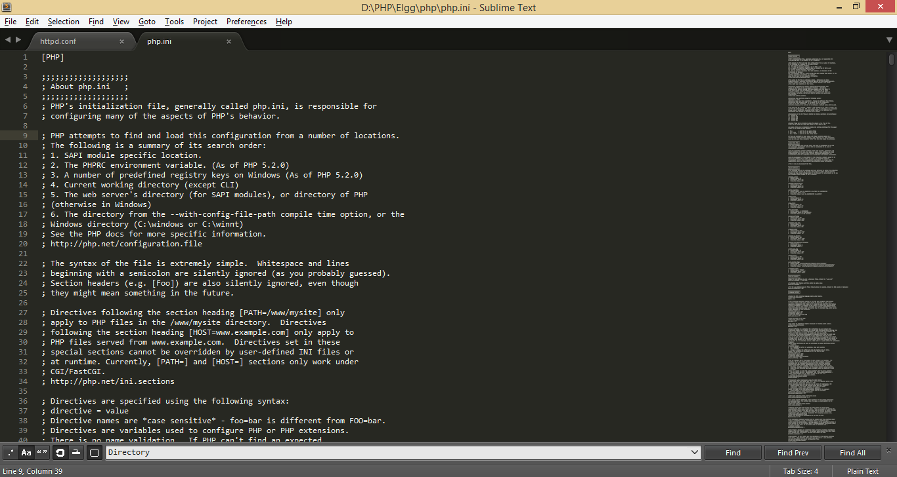

* Sửa **;** **extension_dir = "ext"** thành **extension_dir = "****D:/PHP/Elgg/php/ext"**
* Tạo thư mục lưu sessions sửa **;session.save_path = "/tmp"** thành **session.save_path = “****D:/PHP/Elgg/php/sessions"**
* Sửa **error_reporting = E_ALL** thành **error_reporting = E_ALL** **& ~E_NOTICE & ~E_WARNING** để tắt các cảnh báo trên trình duyệt
* Bỏ dấu **;** trong **;****extension=php_mysql.dll** thành **extension=php_mysql.dll**
* **;****extension=php_gd2.dll** thành **extension=php_gd2.dll**
* Cấu hình Apache làm việc với PHP
  + Sửa **httpd.conf** thêm vào cuối các dòng sau

*PHPIniDir "D:/PHP/Elgg/php"*

*LoadModule php5_module "D:/PHP/Elgg/php/php5apache2_4.dll"*

*AddHandler application/x-httpd-php .php*

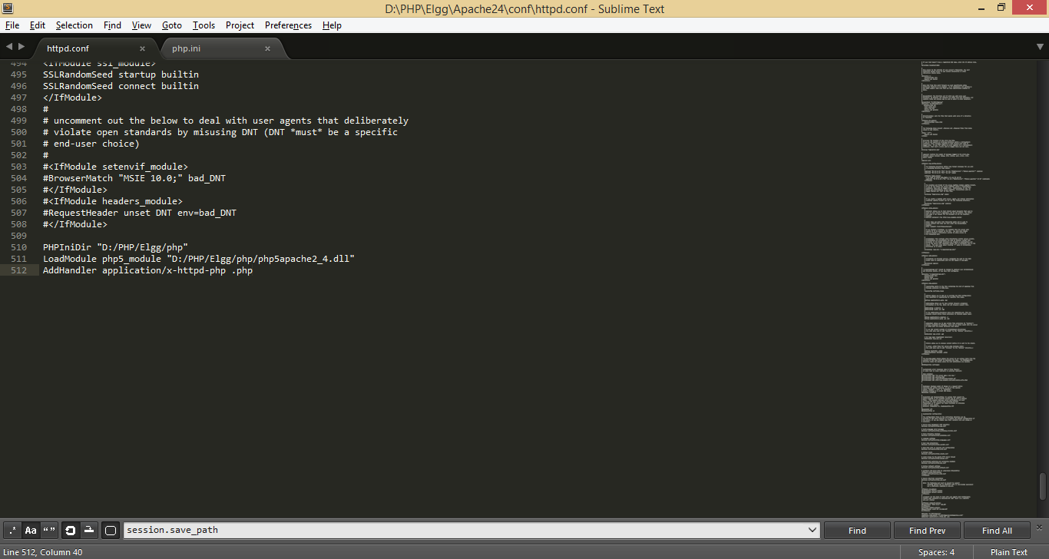

* Sửa **DirectoryIndex index.html** thành **DirectoryIndex** **index.php index.html**
* Restart lại Apache

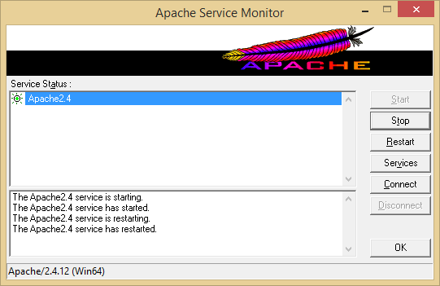

* Tạo 1 File index.php trong ../www để Test Server

*<?php*

*phpinfo();*

*?>*

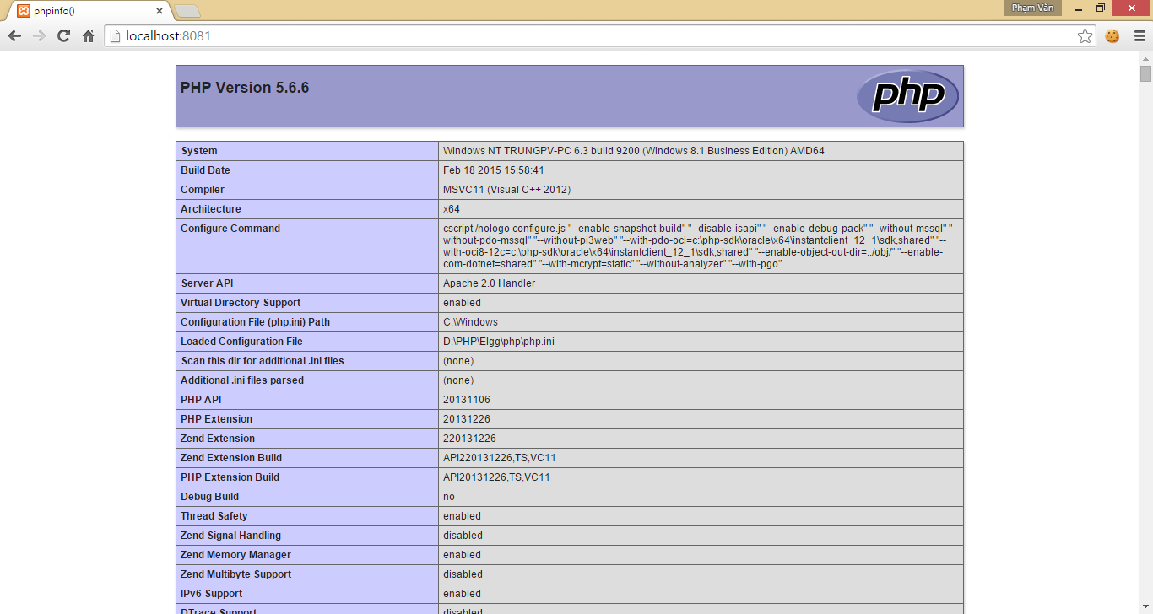

* Tiếp đến cài MySQL download file cài đặt về va làm theo hưỡng dẫn ta được như hình sau

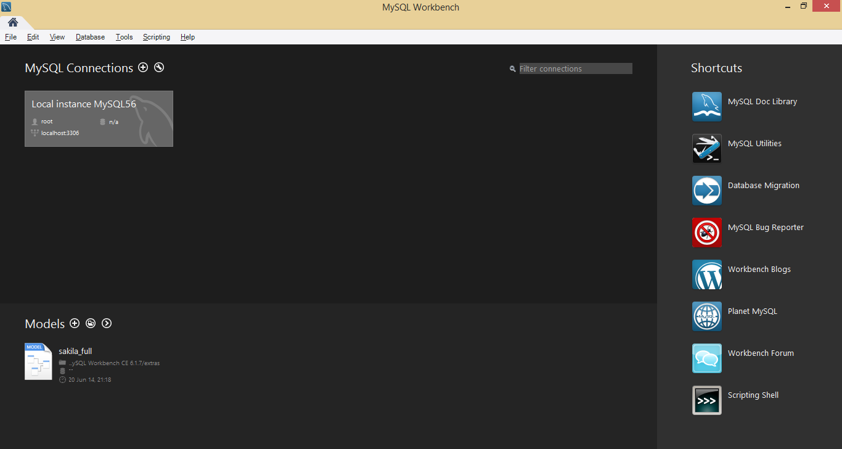

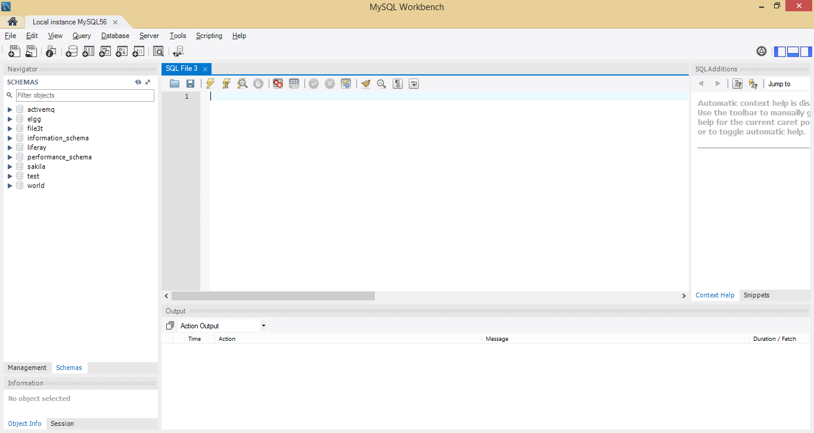

Hoàn thành cài đặt ;)

### Linux

* Trên Linux mình sẽ cài đặt trên Ubuntu.
* Các bước cài đặt thực hiện các câu lệnh sau:
  + Cài Apache
    - sudo apt-get update
    - sudo apt-get install apache2
* Cài MySQL
  + sudo apt-get install mysql-server libapache2-mod-auth-mysql php5-mysql
  + sudo mysql_install_db
  + sudo /usr/bin/mysql_secure_installation
* Cài PHP
  + sudo apt-get install php5 libapache2-mod-php5 php5-mcrypt
* Enable Module
  + sudo apt-get install php5-curl php5-gd
* Sau thi thực hiện các bước ta kiểm tra và restart apache
  + sudo service apache2 restart
* Tham khảo: <https://www.digitalocean.com/community/tutorials/how-to-install-linux-apache-mysql-php-lamp-stack-on-ubuntu>

#### Cài đặt Elgg

* Download source từ trang chủ <http://elgg.org/download.php> (<http://elgg.org/getelgg.php?forward=elgg-1.10.3.zip>)
* Tao copy bỏ vào **D:\PHP\Elgg\www** và giải nén ta được

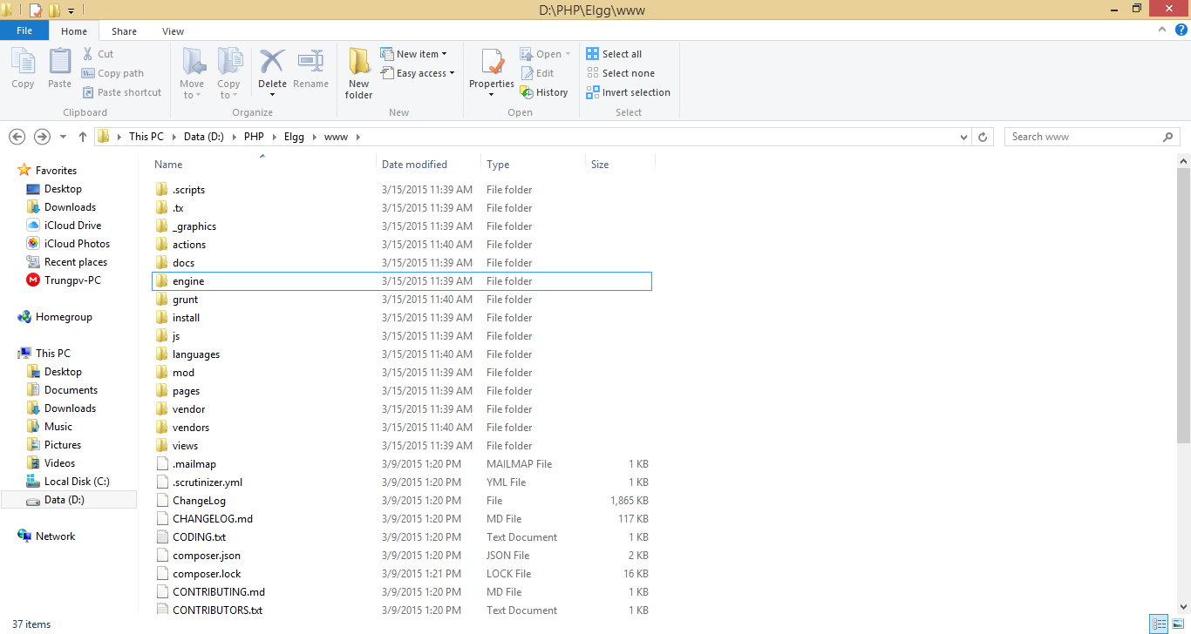

* Vào Workbench và tạo database là **elgg**

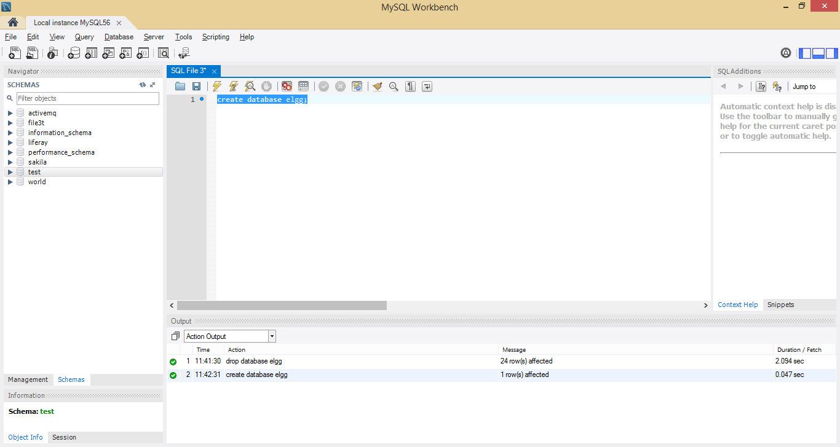

* Sau đó ta mở trình duyệt vào đường link <http://localhost:8081/install.php> tiến hành cài đặt

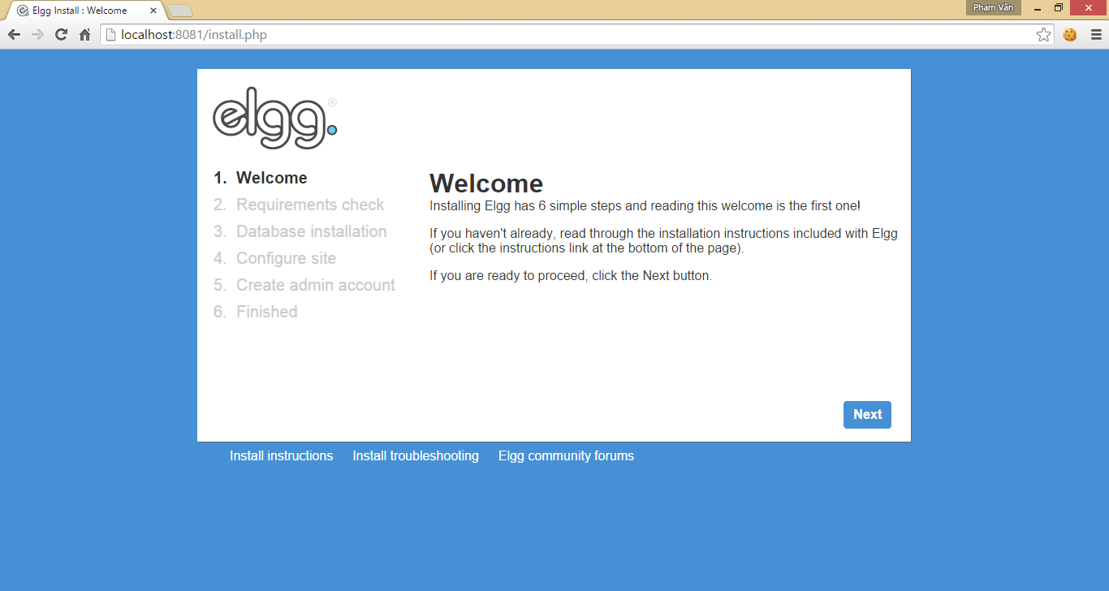

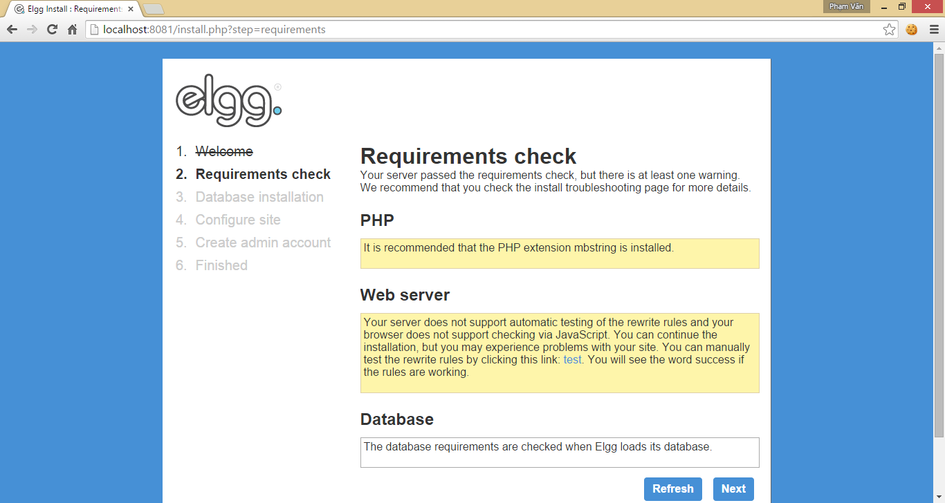

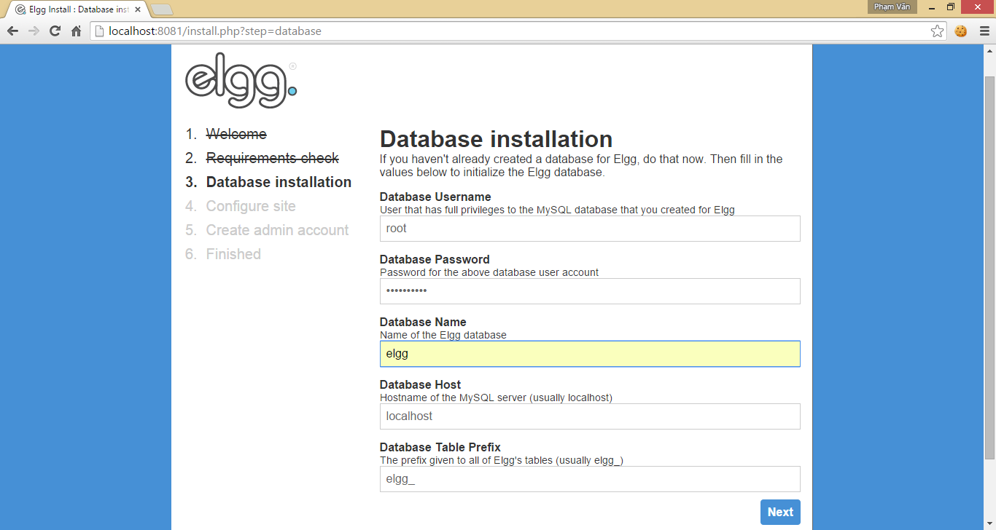

* Tạo thư mục D:\PHP\Elgg\www\data

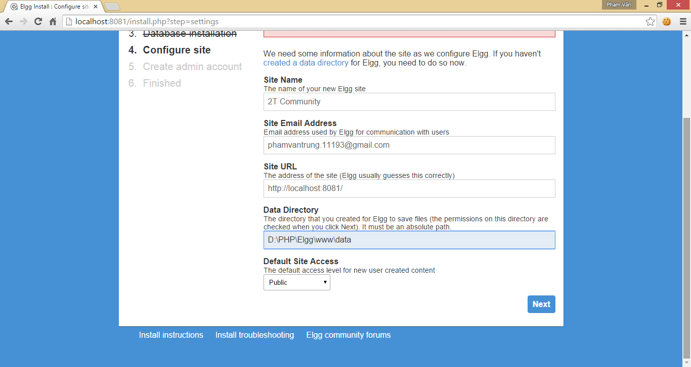

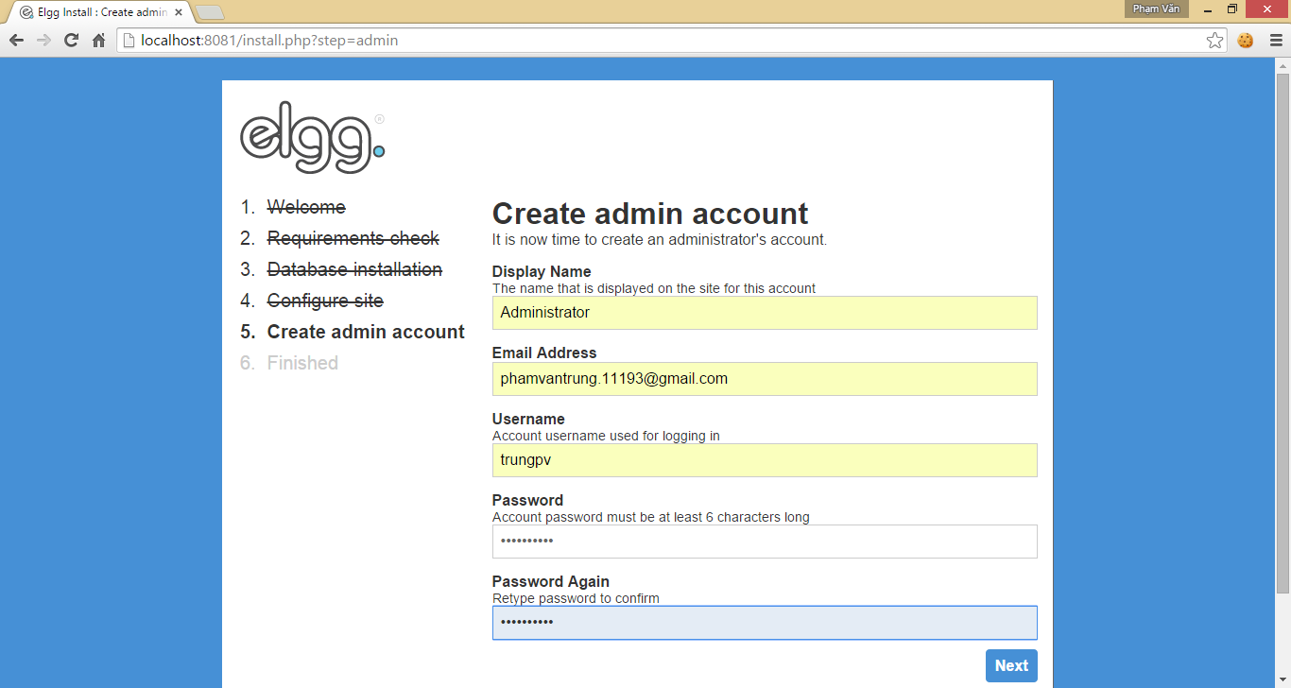

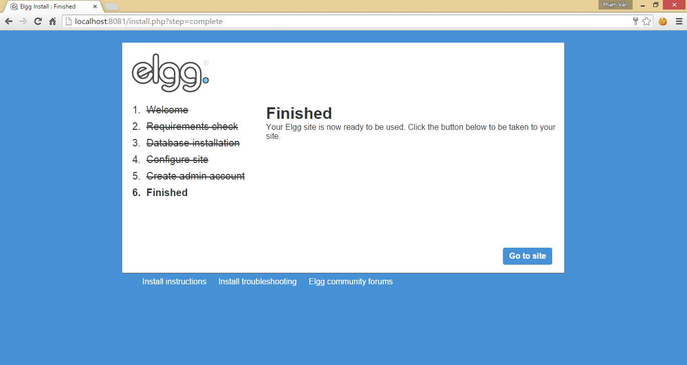

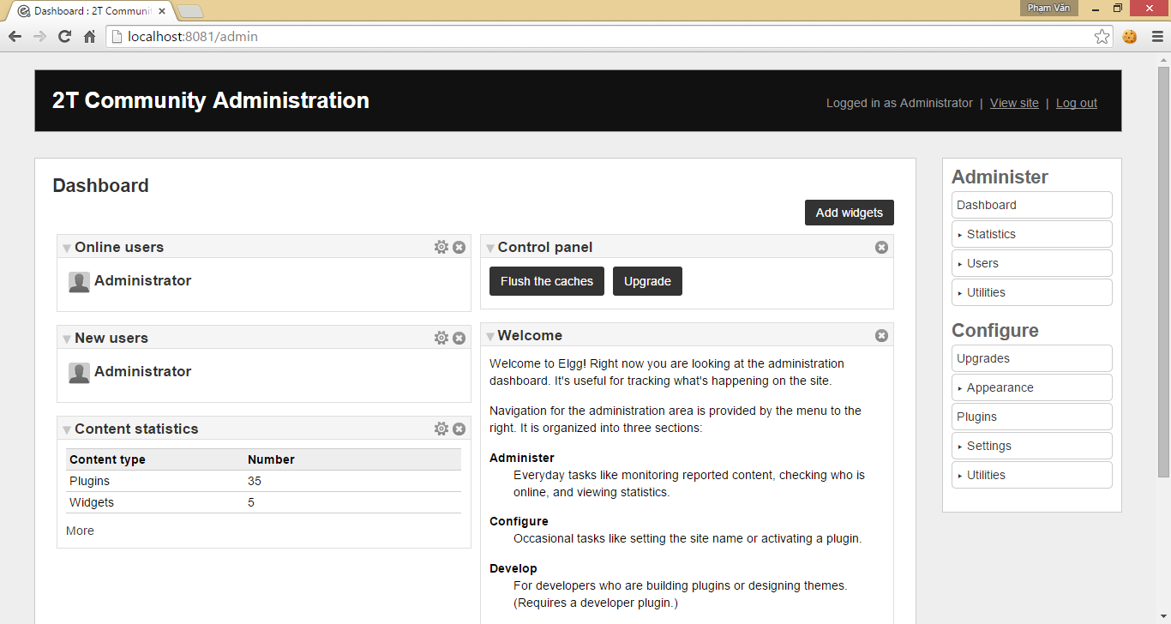

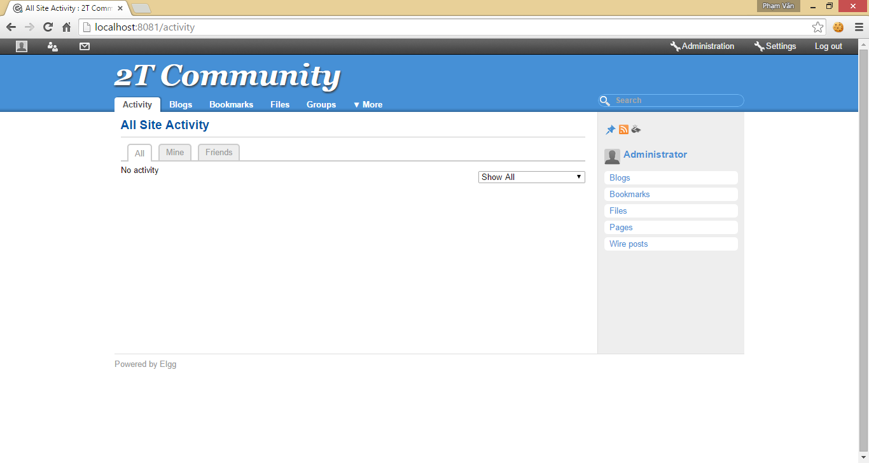

# Cấu trúc database của Elgg, Database model

## Cấu trúc database của Elgg

Trong Elgg, tất cả mọi thứ đều hoạt động trên một mô hình dữ liệu thống nhất dựa trên các đơn vị nguyên tử của dự liệu được gọi là entities – thực thể.

Plugins không được khuyến khích tương tác trực tiếp với cơ sở dữ liệu, để tạo ra một hệ thống ổn định hơn và trải nghiệm người dùng tốt hơn vì nội dung được tạo ra bởi các plugin khác nhau có thể được pha trộn với nhau theo những cách thức phù hợp. Với cách tiếp cận này, plugins được phát triển nhanh hơn, đồng thời mạnh mẽ hơn nhiều.

Mỗi entity - thực thể trong hệ thống kế thừa từ lớp ElggEntity. Lớp này kiểm soát quyền truy cập, quyền sở hữu.

Có thể mở rộng các đối tượng có thông tin thêm trong hai cách:

* Metadata: đây là thông tin mô tả các thực thể, thường thêm vào bởi tác giả của các thực thể khi nó được tạo ra. Ví dụ, thẻ, số ISBN, vị trí tập tin, hoặc mã nguồn ngôn ngữ là metadata - siêu dữ liệu.
* Annotations: đây là thông tin về các thực thể, thường thêm bởi bên thứ ba sau khi các thực thể được tạo ra. Ví dụ, xếp hạng, like, và votes, comment.

**Sơ đồ EER của database Elgg:**

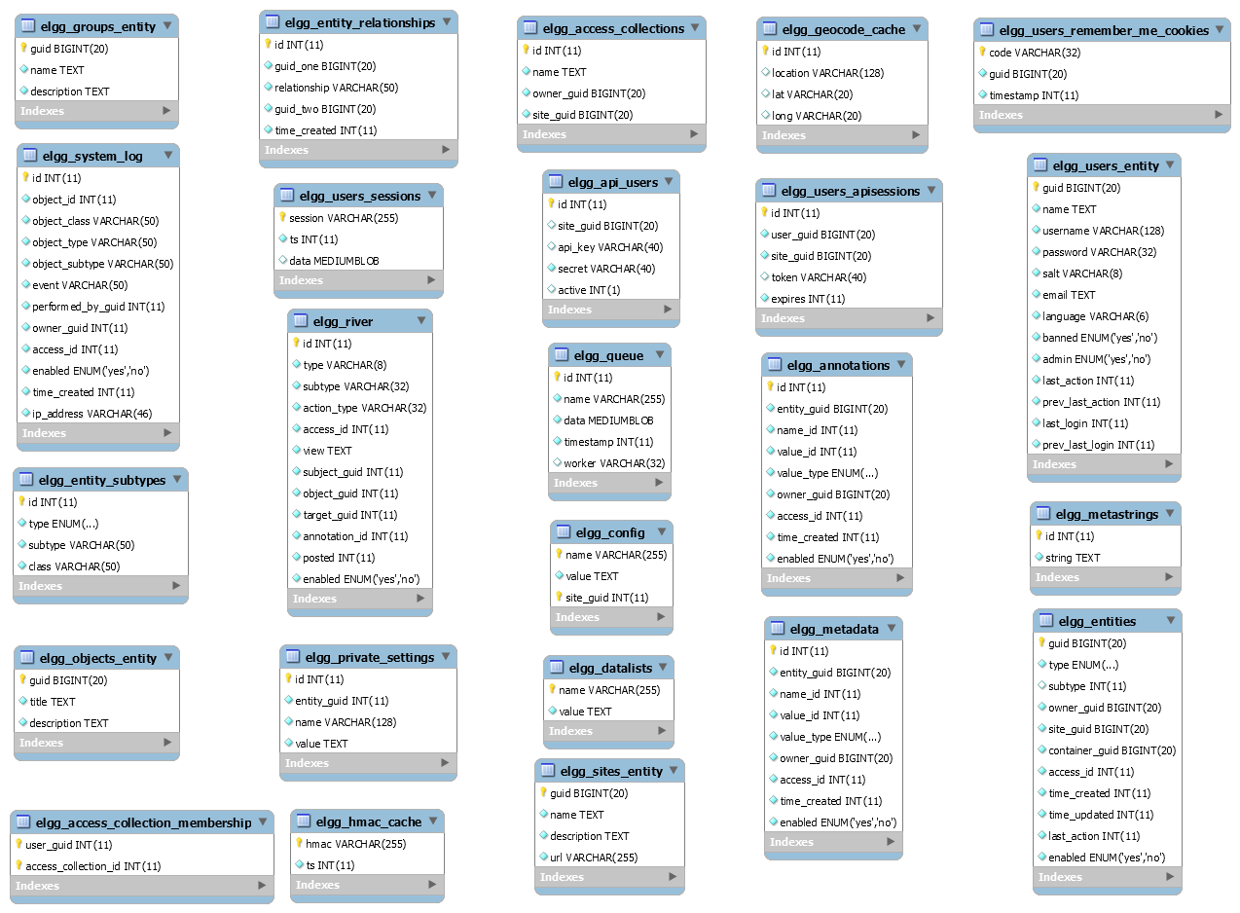

* Mỗi bảng trong elgg được bắt đầu bằng một prefix - tiền tố tùy chọn khi cài đặt elgg, trong hình thì prefix là “elgg_” và mặc định khi cài đặt elgg thì prefix cũng sẽ là “elgg_”.

**Danh sách các bảng và thuộc tính của chúng**

* + entities (elgg_entities): Đây là bảng Entities chính chứa Elgg user, sites, objects và group.
    - guid: id tăng tự động
    - type: Loại thực thể - object, user, group hay site
    - subtype: liên kết với bảng entity_subtypes
    - owner_guid: id chủ sở hữu
    - site_guid: chứa id Site sở hữu
    - container_guid: thực thể này chứa bởi 1 người dùng hay group người dùng
    - access_id: id quyền truy cập
    - time_created: thời gian tạo
    - time_updated: thời gian cập nhật
    - enabled: trạng thái kích hoạt
  + entity_subtypes (elgg_entity_subtypes):
    - id:
    - type: Loại Entity – object, user, site, và group
    - subtype: Tên subtype
    - class: Tên của Lớp (class) vd: ElggPlugin, ElggFile, ElggWidget…
  + metadata (elgg_metadata):
    - id:
    - entity_guid: id Entity đính kèm
    - name_id: liên kết với bảng metastrings định nghĩa tên của bảng
    - value_id: liên kết với bảng metastrings định nghĩa giá trị
    - value_type: loại của giá trị vd: class, text, int…
    - owner_guid:
    - access_id:
    - time_created:
    - enable:
  + annotations (elgg_annotations):
    - id:
    - entity_guid: id Entity đính kèm
    - name_id: liên kết với bảng metastrings định nghĩa tên của bảng
    - value_id: liên kết với bảng metastrings định nghĩa giá trị
    - value_type: loại của giá trị vd: class, text, int…
    - owner_guid:
    - access_id:
    - time_created:
    - enable:
  + relationships (elgg_relationships):
    - guid_one: id của entity chính
    - relationship: loại quan hệ
    - guid_two: id của entity đích
  + objects_entity (elgg_objects_entity):
    - Các thông tin thêm liên quan đến đối tượng. Nó để giảm tải các thông tin trên bảng metadata và làm khác biệt giữa thuộc tính và metadata.
  + sites_entity (elgg_sites_entity):
    - Các thông tin thêm liên quan đến sites.
  + users_entity (elgg_users_entity):
    - Các thông tin thêm liên quan đến users.
  + groups_entity (elgg_groups_entity):
    - Các thông tin thêm liên quan đến groups.
  + metastrings (elgg_metastrings):
    - Chứa nội dung của metadata được liên kết với các bảng metadata và annotations.

Tham khảo: <http://learn.elgg.org/en/latest/design/database.html>

## Database model

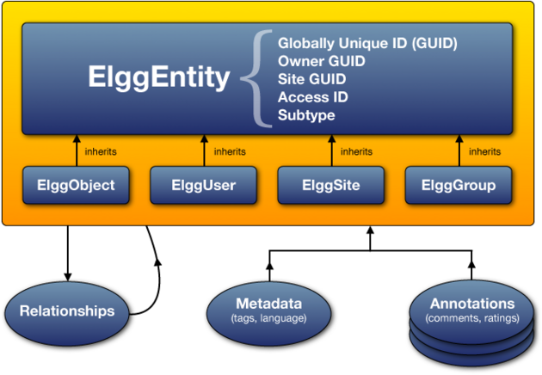

Hình 1: Mô hình dữ liệu của Elgg – nguồn <http://learn.elgg.org/en/latest/design/database.html#datamodel>

Hầu hết các ứng dụng web động sử dụng database cho phần back-end (tất cả những phần liên quan trực tiếp đến database của hệ thống). Hệ quản trị cơ sở dữ liệu mà Elgg sử dụng đó là MySQL. Một trong những điểm tạo nên tính mở rộng cho Elgg đó là Elgg được thiết kết theo cách mà khi một người muốn phát triển một plugin cho Elgg họ không cần phải tạo ra các bảng trong database để lưu dữ liệu của họ. Có được điều đó là do Elgg dựa trên một mô hình dữ liệu có tính linh hoạt và tổng quát cao. Điều đó có nghĩa là khi một sự thay đổi ở database như mở rộng để có thể hỗ trợ cho nhiều server hay do cơ sở hạ tầng thì chúng ta cũng sẽ không cần phải cập nhật hay chỉnh sửa lại code. Toàn bộ các đối tượng trong Elgg đều được lưu dưới dạng Entity và được lưu ở bảng Entity. Một người dùng (user) là một entity, blog cũng là entity.... Elgg đưa ra một lớp cơ sở là ElggEntity, tất cả các enity khác đều kế thừa từ lớp ElggEntity này. Ví dụ như ElggUser kết thừa từ lớp ElggEntity và cung cấp các chức năng của user. Bên cạnh ElggEntity, Elgg cũng cung cấp thêm ba lớp khác để giúp người phát triển có thể thêm các chức năng mới dễ dàng hơn. Ba lớp đó là ElggRelationship, ElggMetadata và ElggAnnotation.

* **ElggRelationship**: cho phép chúng ta có thể thêm các mối quan hệ giữa các đối tượng ví dụ như một user có thể là bạn (friend ) của một user khác hay một user có thể là một thành viên của một group nào đó.
* **ElggMetadata** và **ElggAnnotation** cho phép người phát triển bổ sung thêm các thông tin cho một đối tượng vi dụ như mặc định ElggUser không có thuột tính ngày sinh nhật (dob-date of birth) chúng ta có thể thêm dob cho user bằng cách sử dụng ElggMetadata hay khi một user nào đó bình luận (comment ) một blog của ai đó thì khi đó comment đó sẽ đươc lưu ElggAnnotation cho đối tượng blog.

**Diễn giải các đối tượng**

1. **Entities:** là một lớp cơ sở của Elgg data model.
2. **Users, Objects, Groups, Sites:**

ElggEntity có bốn phần chính, trong đó cung cấp các thuộc tính bổ sung và phương thức để dễ dàng xử lý các loại dữ liệu khác nhau.

**ElggObject**: nội dung như bài đăng trên blog, tải lên các tập tin và các bookmarks **ElggUser**: một người sử dụng hệ thống **ElggSite**: Mỗi Elgg Site ở trong một sự thể hiện của Elgg **ElggGroup**: hệ thống tương tác đa người dùng (được gọi là "cộng đồng" trong các phiên bản trước của Elgg)

Các lợi ích của cách tiếp cận này là, ngoài mô hình hóa dữ liệu một cách dễ dàng hơn, một tập hợp chung các chức năng có sẵn để xử lý các đối tượng, bất kể (sub) type của chúng.

Mỗi thứ có các thuộc tính riêng của chúng mà chúng mang đến cho bảng: ElggObjects có một tiêu đề và mô tả, ElggUsers có một tên người dùng và mật khẩu, vv. Tuy nhiên, bởi vì tất cả chúng đều kế thừa từ ElggEntity, nên chung có một số đặc tính cốt lõi và hành vi chung.

1. **GUIDs**

GUID là một số nguyên xác định duy nhất mỗi thực thể trong một cài đặt Elgg (một IDentifier toàn cục duy nhất). Nó được gán tự động khi các thực thể đầu tiên được lưu lại và không bao giờ được thay đổi.

Một số chức năng của Elgg API làm việc với GUID thay vì đối tượng ElggEntity.

1. **ElggObject**

Các loại thực thể ElggObject đại diện cho nội dung tùy biến trong một thiết lập Elgg; những việc như viết blog, tải lên các tập tin, vv

Ngoài các thuộc tính ElggEntity chuẩn, ElggObjects cũng hỗ trợ:

* ‘tiêu đề’ Tiêu đề của các đối tượng (HTML thoát text)
* ‘Mô tả’ Mô tả các đối tượng (HTML)
* Hầu hết các dữ liệu khác về các đối tượng thường được lưu trữ thông qua siêu dữ liệu.

1. **ElggUser**

Các loại thực thể ElggUser đại diện cho người dùng trong một cài đặt Elgg. Những điều này sẽ được thiết lập vô hiệu hóa cho đến khi tài khoản của họ đã được kích hoạt (trừ khi chúng được tạo ra từ bên trong mảng quản trị).

Ngoài các thuộc tính chuẩn của ElggEntity, ElggUsers cũng hỗ trợ:

‘name’: tên thật của người dùng. ví dụ "Hugh Jackman"

‘username’: tên đăng nhập của họ. Ví dụ: "Hjackman"

‘password’: một phiên bản mảng băm của mật khẩu của họ

‘salt’:

‘salt’: địa chỉ email email của họ

‘language’: mã ngôn ngữ mặc định của họ.

‘code’: mã phiên của họ.

‘last_action’: Các dấu thời gian UNIX của lần cuối cùng họ được tải một trang

‘prev_last_action’: Các giá trị trước đó của last_action

‘last_login’: Các dấu thời gian UNIX của log cuối cùng của họ trong

‘prev_last_login’: giá trị trước đó của last_login

1. **ElggSite**
2. **ElggGroup**

# Metadata

* Metadata trong elgg cho phép bạn lưu trữ thêm dữ liệu vào một entity ngoài các trường mà entity đó hỗ trợ.
* Ví dụ:
  + ElggObjects chỉ hỗi trợ các trường cơ bản như title, description nhưng bạn lại muốn thêm vào trường là tags, số ISBN chẳng hạn.
  + Tương tự vậy bạn có thể cho phép người dùng có thể lưu trữ ngày tháng năm sinh.
* Metadata được lưu trữ như một thể hiện của lớp ElggMetadata, nhưng bạn không cần phải quan tâm (nếu có bạn có thể xem thêm về Lớp ElggMetadata trong reference) điều bạn cần quan tậm là:
  + Metadata đều có một chủ sở hữu và quyền truy cập, cả hai đều có thể khác với chủ sở hữu của các entity nó gắn liền
  + Bạn có thể có nhiều mục cho từng loại metadata gắn liền với một entity.

# Plugins Elgg

* Đầu tiên khi tạo plugin ta cần tạo một thư mục để chứa toàn bộ source trong */mod/ với tên tùy chọn và không được trùng tên với các thư mục của các plugin khác.
* Tiếp theo ta cần tạo và khai báo 2 file là start.php và manifest.xml nằm trong thư mục chính của plugin .
* Start.php: File dùng để đăng kí các sự kiện lắng nghe và plugin hook.
* Activate.php, deactivate.php: là 2 file chứa các hàm và thủ tục được thực thi khi kích hoạt hoặc thu gom rác khi bỏ kích hoạt plugin.
* Manifest.xml: chứa các thông tin về plugin, những yêu cầu để có thể chạy, tùy chọn thông tin được hiển thị trong admin plugin và những API cung cấp.
  + Manifest.xml là một tập tin chuẩn XML và có node cha là thẻ <plugin_manifest>
  + Các thẻ cần thiết:
    - Id: tên thư mục mà plugin sử dụng
    - Name: Tên hiển thị của plugin
    - Author: Tên tác giả
    - Version: Tên phiên bản
    - Description: mô tả chi tiết về plugin các chức năng thông tin liên quan
    - Requires: Thông tin và yêu cầu của plugin cho bản phát hành nào
* Các thẻ có thể có hoặc không:
  + Blurb: mô tả ngắn gọn về plugin
  + Category: category chứa plugin
  + Conflicts: các xung đột mà plugin có thể xảy ra với hệ thống
  + Copyright:
  + License: thông tin về bản quyền
  + Provides:
  + Screenshot:
  + Suggests:
  + Website:
* Ví dụ

|  |
| --- |
| <?xml version="1.0" encoding="UTF-8"?>  <plugin_manifest xmlns="http://www.elgg.org/plugin_manifest/1.8">  <name>Example Manifest</name>  <author>Brett Profitt</author>  <version>1.0</version>  <blurb>This is an example manifest file.</blurb>  <description>This is a simple example of a manifest file. In this example, there are many options used, including screenshots, dependencies, and additional information about the plugin.</description>  <website>http://www.elgg.org/</website>  <copyright>(C) Brett Profitt 2014</copyright>  <license>GNU Public License version 2</license>  <category>3rd_party_integration</category>  <requires>  <type>elgg_release</type>  <version>1.9.1</version>  </requires>  <!-- The path is relative to the plugin's root. -->  <screenshot>  <description>Elgg profile.</description>  <path>screenshots/profile.png</path>  </screenshot>  <provides>  <type>plugin</type>  <name>example_plugin</name>  <version>1.5</version>  </provides>  <suggests>  <type>plugin</type>  <name>twitter</name>  <version>1.0</version>  </suggests>  </plugin_manifest> |

* Cấu trúc một Plugin example hoàn chỉnh như sau:

|  |
| --- |
| actions/  example/  action.php  other_action.php  classes/  ExampleClass.php  graphics/  example.png  js/  example.js  languages/  en.php  lib/  example.php  pages/  example/  all.php  owner.php  vendors/  example_3rd_party_lib/  views/  default/  example/  css.php  forms/  example/  action.php  other_action.php  js/  example.php  object/  example.php  example/  context1.php  context2.php  plugins/  example/  settings.php  usersettings.php  widgets/  example_widget/  content.php  edit.php  activate.php  deactivate.php  CHANGES.txt  COPYRIGHT.txt  INSTALL.txt  LICENSE.txt  manifest.xml  README.txt  start.php |

* + Các File cần phải có:

|  |
| --- |
| mod/example/  start.php  manifest.xml |

* Actions: thư mục actions/ chứa các file php chưa các hành động thao tác của plugin.
* Text Files: Bao gồm các file tài liệu, hưỡng dẫn, bản quyền...
  + README.txt: Những thông tin thêm về Plugin
  + COPYRIGHT.txt: Nếu có thì phải cung cấp các thông tin về bản quyền plugin.
  + LICENSE.txt: Nếu có thì phải cung cấp các giấy phép mà plugin sử dụng.
  + INSTALL.txt: Nếu có thì phải cung cấp các thông tin về cài đặt và các API.
  + CHANGES.txt: Nếu có thì cung cấp các thông tin về thay đổi, phiên bản, và phiên bản mới nhất đặt đầu tiên.
* Pages
* Classes
* Vendors
* Lib
* Views
* Javascript:
* activate.php and deactivate.php: là 2 file chứa các hàm và thủ tục được thực thi khi kích hoạt hoặc thu gom rác khi bỏ kích hoạt plugin.

# Các chức năng của gjobs

## Register

### Register normally

Sơ đồ DFD



|  |
| --- |
| **Use case**: Register (normal) |
| **Actor:** individuals (students, worker), companies |
| **Description:** |
| **Trigger:** |
| **Preconditions:**  System is running  Database is up-to-date, on-line |
| **Normal course:**  N1. Individuals provide **first_name**, **last_name**, **email**, **password** (2 times), **gender** (male-female), **is student or worker**. Companies provide **company_name**, **first_name** and **last_name** of registers, **email**, **password** (2 times)  N2. The system check the email whether the email existed, password and confirming password are the same  N3. Create an account for actor but this account is not active.  ~~N4. The system saves creating a new account into log table (id of new account, type of action, creating time)~~  N5. The system sends an email that includes an active link to the email address of actors  N6. Actors click the active link and will be redirect to active page of GJOBS. Then the account will be active officially  ~~N7. The system saves an account active into log table (id of new account, type of action, active time)~~ |
| **Alternative course:**  A2-a. Email of register existed  A2.a.1 Require enter other email address  A2-b. Password and confirming password are not correct  A2.-b.1. Re-enter passwords |
| **Exceptions:** |
| **Post-conditions:**  New account |

**Một số vị trí liên quan để customize:**

Được thực hiện trong: plugin gjobs và useremailvalidate

Gjobs:

Action:

* actions/register_individual.php
* actions/register_company.php

Library:

* lib/registerIndividiual
* lib/registerCompany

Pages:

* pages/account/register.php
  + elgg_require_js("gjobs/register_via_facebook"): views/default/js/gjobs

### Register via other social networks (Facebook, Google +, Twitter, Linkedin)

Sơ đồ DFD



|  |
| --- |
| **Use case:** Register via other social networks (Facebook, Google +, Twitter, Linkedin) |
| **Actor:** individuals (students, worker) |
| **Description:** |
| **Trigger:** |
| **Preconditions:**  System is running  Database is up-to-date, on-line |
| **Normal course:**  N1. Individuals provide **email**, **password** of other social networks, verify they are **students or workers**  N2. The system log in other social networks and get information of actors  N3. Create an account for actor but this account is not active  N5. The system saves creating a new account into log table (id of new account, type of action, creating time)  N6. The system sends an email that includes an active link to the email address of actors  N7. Actors click the active link and will be redirect to active page of GJOBS. Then the account will be active official  N8. The system saves an account active into log table (id of new account, type of action, active time) |
| **Alternative course:** |
| **Exceptions:** |
| **Post-conditions:**  New account |

**Một số vị trí liên quan để customize:**

Xử lý: plugin gjobs và social_login

Gjobs

Pages:

* pages/register.php

## Sign in

Sơ đồ DFD:





|  |
| --- |
| **Use case:** Sign in |
| **Actor:** administrators- subAdministrators, individuals (students, worker), companies |
| **Description:** |
| **Trigger:** |
| **Preconditions:**  System is running  Database is up-to-date, on-line |
| **Normal course:**  N1. Actors inputs **email** and **password**  N2. The system gets email and password based on **email** from database  N3. The system compares email and password of inputs to email a password in database  ~~N4. The system saves action sign-in into log table (id of account, type of action, sign-in time)~~ |
| **Alternative course:**  A1-a. Signing-in has failed 3 times  A1.1. The account is locked temporarily and redirect to the page resetting password  ~~A1.2. The system saves the action “fail 3 times” into log table (id of account, type of action, time)~~  A1.3. Actor inputs email which was used to register the account to receive the links for resetting password  A1.4. The system send the link for resetting password to the email of user  A1.5. In the reset password page, actor determine new password and confirm new password  A1.6. The system saves new password  A1.7. The system saves the action “new password” into log table (id of account, type of action, time) |
| **Exceptions:** |
| **Post-conditions:**  Log in is successful or not successful |

**Một số vị trí liên quan để customize:**

Được thực hiện trong: plugin gjobs (action: login)

Gjobs

Action:

* actions/login.php

## Change password



|  |
| --- |
| **Use case:** Change password |
| **Actor:** administrators- subAdministrators, individuals (students, worker), companies |
| **Description:** |
| **Trigger:** actors want to change password |
| **Preconditions:**  Account is authenticated  System is running  Database is up-to-date, on-line |
| **Normal course:**  N1. Actors inputs **newpassword** and **confirming password**  N2. The system compares **newpassword** and **confirming password** that are equal  N3. The system saves **newpassword** into database  ~~N4. The system saves the action “change password” into log table (id of account, type of action, changing-password time)~~ |
| **Alternative course:**  A2-a. newpassword and confirmingpassword are not equal  A2-a.1 Re-enter newpassword and confirmingpassword |
| **Exceptions:** |
| **Post-conditions:**  New password |

Sử dụng mặc định hệ thống

## Remember me



|  |
| --- |
| **Use case:** Remember me |
| **Actor:** administrators- subAdministrators, individuals (students, worker), companies |
| **Description:** |
| **Trigger:** |
| **Preconditions:**  Account is authenticated  System is running  Database is up-to-date, on-line |
| **Normal course:**  N1.The system save current **email** and **password** to a cookie for next signing-in |
| **Alternative course:** |
| **Exceptions:** |
| **Post-conditions:**  New password |

Sử dụng mặc định hệ thống

## Forgot the password

Sơ đồ DFD



|  |
| --- |
| **Use case:** forgot the password |
| **Actor:** administrators- subAdministrators, individuals (students, worker), companies |
| **Description:** |
| **Trigger:** |
| **Preconditions:**  System is running  Database is up-to-date, on-line |
| **Normal course:**  N1. The system redirect the actors to screen “forgot the password”  N2. Actors enter **email** which was used to register to receive the **link** for reset the password  N3. The system send the email for the reset the password to the email of actor  N4. Actors visit the new screen where they enter **new password** and **confirm new password**  N5. The system saves the action “change password” into log table (id of account, type of action, changing-password time) |
| **Alternative course:** |
| **Exceptions:** |
| **Post-conditions:**  New password |

Sử dụng mặc định

**Một số vị trí liên quan để customize:**

Gjobs

Action:

* actions/users/requestnewpassword.php
* actions/users/reset_password.php

## Search information in general

Sơ đồ DFD:



|  |
| --- |
| **Use case:** Search information |
| **Actor:** administrators- subAdministrators, individuals (students, worker), companies |
| **Description:** |
| **Trigger:** |
| **Preconditions:**  Account is authenticated  System is running  Database is up-to-date, on-line |
| **Normal course:**  N1. Actors provide the string for searching  N2. The system compares the string with ***name_of_individuals****,* ***current_job_of_individuals****,* ***name_of_companies****,* ***name_of_ groups_of_career*** *or* ***name_of_groups_of_school, name of employment***  N3. The system shows results to actors as follow:   * ***Individuals***(students, worker)*: Last_name+first_name, avatar, number of followers, current job, current company, type of element* * ***Employments****: Name of job, name of company, salary ( fixed or deal), type of element* * ***Company****: name of company, avatar, numbers of followers, field of company or career, type of element* * ***Group of career****: name of group, avatar, numbers of members, type of element* * ***Group of schools****: name of group, avatar, number of members, type of element* |
| **Alternative course:** |
| **Exceptions:** |
| **Post-conditions:**  Results are showed |

**Một số vị trí liên quan để customize:**

Gjobs:

Pages:

Pages/ search/search.php

Pages/ search/search_ajax.php

## Invite friends from other social networks (Facebook, Google +, Twitter, Linkedin)

Sơ đồ DFD:



|  |
| --- |
| **Use case:** Invite friends from other social networks (Facebook, Google +, Twitter, Linkedin) |
| **Actor:** individuals (students, worker), companies |
| **Description:** |
| **Trigger:** |
| **Preconditions:**  Account is authenticated  System is running  Database is up-to-date, on-line |
| **Normal course:**  N1. Actors choose a specific social network and provide email and password to sign in the social network  N2. The system get list of email addresses of friends of the actors in the other social networks  N3. Actors choose list of email addresses of their friends who they want to invite  N4. The system sends emails including a link which links to main page of GJOBS to email addresses of friends  N5. The system saves the action “invite friends” into log table (id of account, type of action, email of friend, socialnetwork, inviting time) |
| **Alternative course:** |
| **Exceptions:** |
| **Post-conditions:**  Inviting emails are sent |

**Một số vị trí liên quan để customize:**

Gjobs:

Views:

Views/Default/js/gjobs/register_via_facebook.js

## View basic information of other Indiviaduals

Sơ đồ DFD:



|  |
| --- |
| **Use case:** View basic information of other individuals |
| **Actor:** individuals (students, worker), companies |
| **Description:** |
| **Trigger:** |
| **Preconditions:**  Account is authenticated  System is running  Database is up-to-date, on-line |
| **Normal course:**  N1. Actors provide an email or id of other individuals that they want to view  N2. The system loads basic information of the target user including avatar, first name + last name, state of job (working, finding job, studying), current job item ( name of current job , country where they work for, career, name of current company, level of position) name of previous company, name of school (pick the latest school in education), numbers of followers, numbers of connections.  N3. The system shows basic information to the actors  ~~N4. The system saves the action “view basic information of other individuals” into log table (id of account, type of action, id of target account, viewing time)~~ |
| **Alternative course:** |
| **Exceptions:** |
| **Post-conditions:**  Basic information of the target account |

Gjobs:

Pages:

Pages/Profile/view.php

## View full profile of other individuals

Sơ đồ DFD:



|  |
| --- |
| **Use case:** View full profile of other individuals |
| **Actor:** individuals (students, worker), companies |
| **Description:** |
| **Trigger:** |
| **Preconditions:**  Account is authenticated  System is running  Database is up-to-date, on-line |
| **Normal course:**  N1. Actors provide an email or id of other individuals that they want to view  ~~N2. The system checks connection between actors and target individuals. If the target individuals has applied to the employment of the company (current actor), the actor can view full profile of the target as connection even there is no connection between them. Or if the current actor is VIP company, the current actor can view full profile of the individual without any requirement including ignore privacy~~  N3. The system load privacy of the target individuals  N4. The system loads information based on privacy (if the current actor is VIP company, the filter step based on privacy will be removed):   * **Basic information** of the target user including avatar, first name + last name, state of job (working, finding job, studying), current job item ( name of current job, country where they work for, career, name of current company, level of position) name of previous company, name of school (pick the latest school in education), numbers of followers, numbers of connections; *(always public)* * **Backgrounds** including summary, file cv, experiences (each experience item contains name of job, name of company-include a link to the main page of company, logo of company, starting date- ending date or up to now, level of position, location, description of experiences); (*always public*) * **Skills** (each skill item has its name); (*always public* ) * **Education** (each item will contain name of school, degree, major, starting year-ending year, logo of school); (*always public* ) * **Contact info (**email, birthday, IM-online account, interests, phone, address, marital status**);** (based on privacy public, connections or private ) * **Applied jobs** (name of job, avatar of company, name of company, field of company or career, applied date); (based on privacy public, connections or private ) * **References** (name of users, avatar, current job, name of company), (based on privacy public, connections or private ) * **Connections** (name of users, avatar, current job, name of company), (based on privacy public, connections or private ) * **Groups** (Logo, name of group), (based on privacy public, connections or private ) * **Companies followed** (Logo, name of company, field of company or career), (based on privacy public, connections or private ) * **Professional photos** (file picture) (based on privacy public, connections or private )   N5. The system saves the action “view full profile of other individuals” into log table (id of account, type of action, id of target account, viewing time)  N6. The system show full profile to actors |
| **Alternative course:**  E2-~~a.There is no connection between actors and target individuals~~  ~~E2-a.1 Actors need to send a request to view full profile to target individuals and wait for answer. The target need to accept the request if it’s ok for the actors view the full profile~~ |
| **Exceptions:** |
| **Post-conditions:**  Full profile of the target |

**Một số vị trí liên quan để customize:**

Gjobs:

Pages:

Pages/profile/view.php

## Edit basic information of individuals (owner)

Sơ đồ DFD:



|  |
| --- |
| **Use case:** edit basic information (owner) |
| **Actor:** individuals (students, worker) |
| **Description:** |
| **Trigger:** |
| **Preconditions:**  Account is authenticated  System is running  Database is up-to-date, on-line |
| **Normal course:**  N1. Actors determine which information (avatar ,last name, first name,state of job (working, finding job, studying), current job ( name of current job , country where they work for, career, name of current company, level of position), name of previous company, name of school) (**exactly is id of edited information**) is edit and new information.  N2. The system validates new values based on id of information  N3. The system saves new values  N4. The system saves the action “edit basic information” into log table (id of account, type of action, id of edited item, editing time) |
| **Alternative course:** |
| **Exceptions:** |
| **Post-conditions:**  New basic information |

**Một số vị trí liên quan để customize:**

Gjobs:

Actions:

Actions/profile/edit.php

Pages:

Pages/profile/edit.php

Forms:

Views/default/forms/profile/edit.php

## Edit background of individuals (owner)

Sơ đồ DFD:



|  |
| --- |
| **Use case:** edit background (owner) |
| **Actor:** individuals (students, worker) |
| **Description:** |
| **Trigger:** |
| **Preconditions:**  Account is authenticated  System is running  Database is up-to-date, on-line |
| **Normal course:**  N1. Actors determine which information (summary, file cv, experience item *(logo ,Name of company, name of job, location, starting date-ending date or up to now, description of the job)*) (**exactly is id of edited information**) is edit and new information.  N2. The system validates new values based on id of information  N3. The system saves new values  N4. The system saves the action “edit background information” into log table (id of account, type of action, id of edited item, editing time) |
| **Alternative course:** |
| **Exceptions:** |
| **Post-conditions:**  New background information |

**Một số vị trí liên quan để customize:**

Gjobs:

Actions:

Actions/profile/background/edit.php

Pages:

Pages/profile/edit.php

Forms:

Views/default/forms/profile/background/edit.php

## Add new photos to professional photo section

Sơ đồ DFD:



|  |
| --- |
| **Use case:** Add new photo to professional photo section |
| **Actor:** individuals (students, worker) (owner) |
| **Description:** |
| **Trigger:** actors want to add new photo to professional photo section |
| **Preconditions:**  Account is authenticated  System is running  Database is up-to-date, on-line |
| **Normal course:**  N1. Actors specific directory of the file in local computer and description of the file and location will be used to save in photo store  N2. The system uploads the file to server and saves directory of the file, id of actor, description and uploading time to database  N3. The system creates a status whose content is the uploaded photo  N4.The system saves logItem of action “upload new photo” to database (id of actor, action, name of file, uploading time) |
| **Alternative course:** |
| **Exceptions:** |
| **Post-conditions:**  New photos in professional photo section |

**Một số vị trí liên quan để customize:**

Gjobs

Actions:

Actions/profile/proPhotos/edit.php

Forms:

Views/default/forms/profile/proPhotos /edit.php

## Remove a photo from professional photo section

Sơ đồ DFD:



|  |
| --- |
| **Use case:** remove a photo from professional photo section |
| **Actor:** individuals (students, worker) (owner) |
| **Description:** |
| **Trigger:** actors want to remove a photo from professional photo section |
| **Preconditions:**  Account is authenticated  System is running  Database is up-to-date, on-line |
| **Normal course:**  N1. Actors specific photo id (directory of file in photo store)  N2. The system deletes the specific file from store  N3.The system saves logItem of action “delete a professional photo” to database (id of actor, action, name of file, deleting time) |
| **Alternative course:** |
| **Exceptions:** |
| **Post-conditions:**  A removed photo |

**Một số vị trí liên quan để customize:**

Gjobs

Actions:

Actions/profile/proPhotos/delete.php

## Add new experience items to experiences of background of individuals (owner)

Sơ đồ DFD:



|  |
| --- |
| **Use case:** add new experience items to experiences of background of individuals |
| **Actor:** individuals (students, worker) |
| **Description:** |
| **Trigger:** |
| **Preconditions:**  Account is authenticated  System is running  Database is up-to-date, on-line |
| **Normal course:**  N1. Actors provide new experience item (logo, *Name of company, name of job, location, starting date-ending date or up to now, description of the job, level of position*)  N2. The system validates new values  N3. The system saves new values  N4. The system saves the action “add new experience items” into log table (id of account, type of action, id of new experience item, editing time) |
| **Alternative course:** |
| **Exceptions:** |
| **Post-conditions:**  New experience item is added |

**Một số vị trí liên quan để customize:**

Gjobs

Actions:

Actions/profile/experiences/edit.php

Pages:

Pages/profile/experiences/add.php

Forms:

Views/default/forms/profile/experiences/add.php

## Remove skills of individuals (owner)

Sơ đồ DFD:



|  |
| --- |
| **Use case:** remove skills (owner) |
| **Actor:** individuals (students, worker) |
| **Description:** |
| **Trigger:** |
| **Preconditions:**  Account is authenticated  System is running  Database is up-to-date, on-line |
| **Normal course:**  N1. Actors determine id of skill which will be removed  N2. The system remove the skills based on id from skills of the individuals  N3. The system saves the action “remove skill” into log table (id of account, type of action, id of removed skill, removing time) |
| **Alternative course:** |
| **Exceptions:** |
| **Post-conditions:**  skills are removed from kills of individuals |

**Một số vị trí liên quan để customize:**

Gjobs

Actions:

Actions/profile/skills/delete.php

## Add new skills of individuals (owner)

Sơ đồ DFD:



|  |
| --- |
| **Use case:** add new skills (owner) |
| **Actor:** individuals (students, worker) |
| **Description:** |
| **Trigger:** |
| **Preconditions:**  Account is authenticated  System is running  Database is up-to-date, on-line |
| **Normal course:**  N1. Actors provide name of skills  N2. The system create a new id and save the new skill into skills of background of individuals  N3. The system saves the action “add new skill” into log table (id of account, type of action, id of new skill, editing time) |
| **Alternative course:** |
| **Exceptions:** |
| **Post-conditions:**  new skills |

**Một số vị trí liên quan để customize:**

Gjobs

Actions:

Actions/profile/skills/edit.php

Pages:

Pages/profile/skills/edit.php

Forms:

Views/default/forms/profile/skills/edit.php

## Add new education_item to education of individuals (owner)

Sơ đồ DFD:



DFD when the school has not existed



|  |
| --- |
| **Use case:** add new education_item to education of individuals (owner) |
| **Actor:** individuals (students, worker) |
| **Description:** |
| **Trigger:** |
| **Preconditions:**  Account is authenticated  System is running  Database is up-to-date, on-line |
| **Normal course:**  N1. Actors provide education_item (id of school, avatar, name of school, starting year-ending year, degree, major, grade, activities_societies, description)  N2. The system validates values  N3. The system adds new education_item to education of individuals  N4. The system saves the action “add new education item” into log table (id of account, type of action, id of new education, adding time) |
| **Alternative course:** |
| **Exceptions:** |
| **Post-conditions:**  new education_item |

**Một số vị trí liên quan để customize:**

Gjobs

Actions:

Actions/profile/education/edit.php

Pages:

Pages/profile/ education /add.php

Forms:

Views/default/forms/profile/ education /add.php

## Edit education_item to education of individuals (owner)

Sơ đồ DFD:



|  |
| --- |
| **Use case:** edit education_item to education of individuals (owner) |
| **Actor:** individuals (students, worker) |
| **Description:** |
| **Trigger:** |
| **Preconditions:**  Account is authenticated  System is running  Database is up-to-date, on-line |
| **Normal course:**  N1. Actors provide id of education_item (id of school, avatar, name of school, starting year-ending year, degree, major, grade, activities_societies, description) and new values  N2. The system validates values  N3. The system updates education_item to education of individuals  ~~N4. The system saves the action “edit education item” into log table (id of account, type of action, id of updated education, time)~~ |
| **Alternative course:** |
| **Exceptions:** |
| **Post-conditions:**  Updating education_item |

**Một số vị trí liên quan để customize:**

Gjobs

Actions:

Actions/profile/education/edit.php

Pages:

Pages/profile/ education / edit.php

Forms:

Views/default/forms/profile/ education / edit.php

## Edit contact info of individuals

Sơ đồ DFD:



|  |
| --- |
| **Use case:** edit contact info of individuals (owner) |
| **Actor:** individuals (students, worker) |
| **Description:** |
| **Trigger:** |
| **Preconditions:**  Account is authenticated  System is running  Database is up-to-date, on-line |
| **Normal course:**  N1. Actors provide fields (email, birthday, IM, interests, phone, address, marital status) and new values that will be updated  N2. The system validates values  N3. The system updates new contact info  N4. The system saves the action “edit contact info” into log table (id of account, type of action, id of edited item, time) |
| **Alternative course:** |
| **Exceptions:** |
| **Post-conditions:**  Updating contact info |

**Một số vị trí liên quan để customize:**

Gjobs

Actions:

Actions/profile/contact/edit.php

Forms:

Views/default/forms/profile/ contact/ edit.php

## Add reference item

Sơ đồ DFD:



|  |
| --- |
| **Use case:** add reference item |
| **Actor:** individuals (students, worker) |
| **Description:** |
| **Trigger:** |
| **Preconditions:**  Account is authenticated  System is running  Database is up-to-date, on-line |
| **Normal course:**  N1. Actors provide id of user who is a reference  N2. The system validates id of reference (exist or not exist)  N3. The system adds the reference to list of references  N4. The system saves the action “add reference” into log table (id of account, type of action, id of reference, time) |
| **Alternative course:**  A2-a.Id of reference is not existed  A2-a.1 notify to actors to modify |
| **Exceptions:** |
| **Post-conditions:**  New reference |

Actions:

Actions/profile/references/edit.php

Pages:

Pages/profile/ references / add.php

Forms:

Views/default/forms/profile/ references / add.php

## Remove a reference

Sơ đồ DFD:



|  |
| --- |
| **Use case:** remove reference |
| **Actor:** individuals (students, worker) |
| **Description:** |
| **Trigger:** |
| **Preconditions:**  Account is authenticated  System is running  Database is up-to-date, on-line |
| **Normal course:**  N1. Actors provide id of reference who will be removed from the list of references  N2. The system validates id of reference (exist or not exist)  N3. The system removes the reference from the list of references  N4. The system saves the action “remove reference” into log table (id of account, type of action, id of reference, time) |
| **Alternative course:**  A2-a.Id of reference is not existed  A2-a.1 notify to actors to modify |
| **Exceptions:** |
| **Post-conditions:**  The reference is removed |

**Một số vị trí liên quan để customize:**

Gjobs

Actions:

Actions/profile/references/delete.php

## Edit privacy for individuals (students, worker)

Sơ đồ DFD:



|  |
| --- |
| **Use case:** Edit privacy |
| **Actor:** individuals (students, worker) (owner) |
| **Description:** |
| **Trigger:** actors want to edit privacy |
| **Preconditions:**  Account is authenticated  System is running  Database is up-to-date, on-line |
| **Normal course:**  N1. Actors specific item of privacy (provide id of privacy item, id of value of privacy item): (type of privacy: public, connection, private)   * Who can see your contact info * Who can see your applied jobs * Who can see your references * Who can see your connections * Who can see your groups * Who can see companies that you follow * Who can see your professional picture   N2. The system saves new privacy based on id of privacy item and value of privacy item.  N3.The system saves new action “edit privacy” into log table (id of account, action, id of privacy item, editing time) |
| **Alternative course:** |
| **Exceptions:** |
| **Post-conditions:**  updated privacy |

**Một số vị trí liên quan để customize:**

Gjobs

Actions:

Actions/profile/privacy/edit.php

Pages:

Pages/profile/ privacy / edit.php

Forms:

Views/default/forms/profile/ privacy / edit.php

## Edit basic information of individuals (after register)

Sơ đồ DFD:



|  |
| --- |
| **Use case:** Edit basic information (after register) |
| **Actor:** individuals (students, worker) |
| **Description:** |
| **Trigger:** after register |
| **Preconditions:**  Account is authenticated  System is running  Database is up-to-date, on-line |
| **Normal course:**  N1. The system loads **schools**, **majors**, **degrees**, **nationalities** to display to actors  N2. Actors choose the **name of university**, **major**, **starting year** and **ending year** for studying at that school, **degree**, **nationality**. This is just a sample of education and will be add to education of the account.  N3. The system saves their information to database  N4. The system saves the action “edit basic information-after register” into log table (id of account, type of action, time) |
| **Alternative course:** |
| **Exceptions:** |
| **Post-conditions:**  Name of university, major, starting year, ending year, degree and nationality are saved |

**Một số vị trí liên quan để customize:**

Gjobs

Actions:

Actions/basic_info_after_registration_individual.php

Forms:

Views/default/forms/user/basic_info_after_registeration_individual.php

## Add an avatar of individuals

Sơ đồ DFD:



|  |
| --- |
| **Use case:** Add an avatar |
| **Actor:** individuals (students, worker) |
| **Description:** |
| **Trigger:** |
| **Preconditions:**  Account is authenticated  System is running  Database is up-to-date, on-line |
| **Normal course:**  N1. Actors provide avatar by choosing a file from their computer or get a photo by using their camera  N2. The system saves their avatar to database  N3. The system saves the action “change avatar” into log table (id of account, type of action, changing-avatar time) |
| **Alternative course:** |
| **Exceptions:** |
| **Post-conditions:**  New avatar |

Sử dụng mặc định hệ thống

## View full profile of other companies

Sơ đồ DFD:



|  |
| --- |
| **Use case:** View full profile of other companies |
| **Actor:** individuals (students, workers), companies |
| **Description:** |
| **Trigger:** |
| **Preconditions:**  Account is authenticated  System is running  Database is up-to-date, on-line |
| **Normal course:**  N1. Actors provide an email or id of other companies that they want to view  N2. The system loads information:   * **Basic information** of the target company including logo, name of company, country (location - city) where they work for, type of company,field of company or career, link to website, address, number of applier, numbers of followers, numbers of connections; *(always public)* * **Backgrounds** including summary (*always public*) * **Employments:** each employment item includes name of job, description of job *(always public* ) * **Contact info (**email, birthday, IM-online account-instant message, interests, phone, address, marital status**);** (*based on privacy public, connections or private* ) * **Connections** (name of users, avatar, current job, name of company), (*based on privacy public, connections or private* ) * **Applied candidates (** name of individuals, avatar, current job, name of company**)** *(based on privacy public, connections or private )* * **Groups** (Logo, name of group), *(based on privacy public, connections or private )* * **Followers** (Avartar, name of follower, current job, name of company *)*   N3. The system show full profile to actors,  N4. The system saves the action “view full profile of other” into log table (id of account, type of action, id of target, time) |
| **Alternative course:**  E2-a.There is no connection between actors and target companies  E2-a.1 Actors need to send a request to view full profile to target companies and wait for answer. The target need to accept the request if it’s ok for the actors view the full profile |
| **Exceptions:** |
| **Post-conditions:** |

**Một số vị trí liên quan để customize:**

Gjobs

Pages:

Pages/profile/ company/view.php

## Edit basic information of profile of companies (owner)

Sơ đồ DFD:



|  |
| --- |
| **Use case:** edit basic information of profile of companies (owner) |
| **Actor:** companies |
| **Description:** |
| **Trigger:** |
| **Preconditions:**  Account is authenticated  System is running  Database is up-to-date, on-line |
| **Normal course:**  N1. Actors determine which information (logo, name of company, location, field of company, type of company, address, link of website) (**exactly is id of edited information**) is edit and new information.  N2. The system validates new values based on id of information  N3. The system saves new values  N4. The system saves the action “edit basic information of profile of company” into log table (id of account, type of action, id of edited item, time) |
| **Alternative course:** |
| **Exceptions:** |
| **Post-conditions:**  Updating basic information of company |

**Một số vị trí liên quan để customize:**

Gjobs

Actions:

Actions/profile/company/basic/edit.php

Pages:

Pages/profile/ edit.php

Forms:

Views/default/forms/profile/company/basic/edit.php

## Edit the introductory paragraph of background of companies (owner)

Sơ đồ DFD:



|  |
| --- |
| **Use case:** edit the introductory paragraph of background of companies (owner) |
| **Actor:** companies |
| **Description:** |
| **Trigger:** |
| **Preconditions:**  Account is authenticated  System is running  Database is up-to-date, on-line |
| **Normal course:**  N1. Actors provide id of introductory paragraph and new content  N2. The system saves new introduction  N3. The system saves the action “edit introductory paragraph of background of companies” into log table (id of account, type of action, time) |
| **Alternative course:** |
| **Exceptions:** |
| **Post-conditions:**  Updating new introductory paragraph |

Actions:

Actions/profile/company/introductory/edit.php

Forms:

Views/default/forms/profile/company/introductory/edit.php

## Edit an employment item of employment section of profile of companies (owners)

Sơ đồ DFD:



|  |
| --- |
| **Use case:** edit an employment item of employment section of companies (owner) |
| **Actor:** companies |
| **Description:** |
| **Trigger:** |
| **Preconditions:**  Account is authenticated  System is running  Database is up-to-date, on-line |
| **Normal course:**  N1. Actors provide id of employment_item, new content (name of job, level of position, min-salary-> max-salary or deal, address, career, degree, age, appearance, description of job, requirement of job, deadline for application)  N2. The system saves the employment_item  N3. The system saves the action “edit an employment item of companies” into log table (id of account, type of action,id of employment item, id of edited fields, time) |
| **Alternative course:** |
| **Exceptions:** |
| **Post-conditions:**  Updating employment_item |

**Một số vị trí liên quan để customize:**

Gjobs

Actions:

Actions/profile/company/employments/edit.php

Pages:

Pages/profile/ company /employments/ edit.php

Forms:

Views/default/forms/profile/company/ employments /edit.php

## View an employment in details

Sơ đồ DFD:



|  |
| --- |
| **Use case:** view an employment in details (owner) |
| **Actor:** companies, individuals (students, worker) |
| **Description:** |
| **Trigger:** |
| **Preconditions:**  Account is authenticated  System is running  Database is up-to-date, on-line |
| **Normal course:**  N1. Actors provide id of employment_item,  N2. The system load content (name of job, level of position, min-salary-> max-salary or deal, address, career, degree, age, appearance, description of job, requirement of job, deadline for application) based on id of employment  N3. The system displayed the employment_item to actors  N4. The system saves the action “view an employment in details” into log table (id of account, type of action, id of company, id of employment, time) |
| **Alternative course:** |
| **Exceptions:** |
| **Post-conditions:**  Details of an employment |

**Một số vị trí liên quan để customize:**

Gjobs

View:

Views/default/profile/company/ employments /item.php

## Apply for an employment of a company

Sơ đồ DFD:



|  |
| --- |
| **Use case:** apply for an employemnt of a company (owner) |
| **Actor:** individuals (students, worker) |
| **Description:** |
| **Trigger:** |
| **Preconditions:**  Account is authenticated  System is running  Database is up-to-date, on-line |
| **Normal course:**  N1. Actors provide id of employment_item,  N2. The system creates applying item (relationship item) include id of employement_item, id of actors, applying time  N3. The system saves this item into list of applying item  N4. The system saves the action “apply for an employment of a company” into log table (id of account, type of action, id of company, id of employment, time) |
| **Alternative course:** |
| **Exceptions:** |
| **Post-conditions:**  New applying item |

**Một số vị trí liên quan để customize:**

Gjobs

Actions:

Actions/profile/company/employments/apply.php

## Post an employment in profile of company

Sơ đồ DFD:



|  |
| --- |
| **Use case:** post an employment in profile of group |
| **Actor:** companies |
| **Description:** |
| **Trigger:** |
| **Preconditions:**  Account is authenticated  System is running  Database is up-to-date, on-line |
| **Normal course:**  N1. Actors provide (name of job, level of position, min-salary-> max-salary or deal, address, career, degree, age, appearance, description of job, requirement of job, deadline for application)  N2. The system creates an employment_item in database. The new information of the new record is saved in database  N3. The system saves id of actor, action, time into log table  N4. The system saves the action “post an employment in profile of company” into log table (id of account, type of action, id of company, id of new employment, time) |
| **Alternative course:** |
| **Exceptions:** |
| **Post-conditions:**  New employment |

**Một số vị trí liên quan để customize:**

Gjobs

Actions:

Actions/profile/company/employments/edit.php

Pages:

Pages/profile/ company/ employments/ add.php

Forms:

Views/default/forms/profile/company/ employments /add.php

## Edit privacy for companies

Sơ đồ DFD:



|  |
| --- |
| **Use case:** Edit privacy |
| **Actor:** companies (owner) |
| **Description:** |
| **Trigger:** actors want to edit privacy |
| **Preconditions:**  Account is authenticated  System is running  Database is up-to-date, on-line |
| **Normal course:**  N1. Actors specific item of privacy (provide id of privacy item, id of value of privacy item): (type of privacy: public, connection, private)   * Who can see your contact info * Who can see your connections * Who can see your applied candidates * Who can see your groups * Who can see your follower   N2. The system saves new privacy based on id of privacy item and value of privacy item.  N3.The system saves new action “edit privacy” into log table (id of account, action, id of privacy item, editing time) |
| **Alternative course:** |
| **Exceptions:** |
| **Post-conditions:**  updated privacy |

**Một số vị trí liên quan để customize:**

Gjobs

Actions:

Actions/profile/company/privacy/edit.php

Pages:

Pages/profile/ company/ privacy / edit.php

Forms:

Views/default/forms/profile/company/ privacy /edit.php

## Search (advanced)

|  |
| --- |
| **Use case:** search (advanced) |
| **Actor:** company (vip) |
| **Description:** |
| **Trigger:** |
| **Preconditions:**  Account is authenticated  System is running  Database is up-to-date, on-line |
| **Normal course:**  N1. Actors provide searching values of profiles (career, level of position, numbers of experience years, name of school, major at school, degree, age, gender, address)  N2. The system bases on searching values to search profiles of individuals  N3. The system saves searching values to database for suggestion in the future |
| **Alternative course:** |
| **Exceptions:** |
| **Post-conditions:**  Suitable profiles of individuals |

**Một số vị trí liên quan để customize:**

Gjobs

Pages:

Pages/search/search.php

## Edit basic information of company(after register)

Sơ đồ DFD:



|  |
| --- |
| **Use case:** Edit basic information of company (after register) |
| **Actor:** companies |
| **Description:** |
| **Trigger:** after register |
| **Preconditions:**  Account is authenticated  System is running  Database is up-to-date, on-line |
| **Normal course:**  N1. The system loads name of company (based on registration step), **field of working of companies, type of company**  to display  N2. The actors provides field of working of the company, type of company ,starting year, address, link of website  N3. The system saves their information to database  N4. The system saves the action “edit basic information-after register” into log table (id of account, type of action, time) |
| **Alternative course:** |
| **Exceptions:** |
| **Post-conditions:**  Name of university, major, starting year, ending year, degree and nationality are saved |

**Một số vị trí liên quan để customize:**

Gjobs

Actions:

Actions/profile/company/basic/edit.php

Forms:

view/default/forms/profile/company/basic/edit.php

## Add an logo of comapny (after-resigter)

Sơ đồ DFD:



|  |
| --- |
| **Use case:** Add an avatar of comapny |
| **Actor:** companies |
| **Description:** |
| **Trigger:** |
| **Preconditions:**  Account is authenticated  System is running  Database is up-to-date, on-line |
| **Normal course:**  N1. Actors provide logo by choosing a file from their compute  N2. The system saves their logo to database  N3. The system saves the action “change logo” into log table (id of account, type of action, changing-logo time) |
| **Alternative course:** |
| **Exceptions:** |
| **Post-conditions:**  New logo |

Sử dụng mặc định hệ thống

## Groups of careers

### Edit profile of group (of career)

Sơ đồ DFD:



|  |
| --- |
| **Use case:** edit profile of group |
| **Actor:** admin, sub-admin, group admin |
| **Description:** |
| **Trigger:** admin, sub-admin edits profiles of group |
| **Preconditions:**  Account is authenticated  System is running  Database is up-to-date, on-line |
| **Normal course:**  N1. Actors provide id of group, new description of profile of group  N2. The system bases on id of group to update new description of group  N3. The system saves id of actors, action, id of group into log table |
| **Alternative course:** |
| **Exceptions:** |
| **Post-conditions:**  New description of group |

**Một số vị trí liên quan để customize:**

Gjobs

Actions:

Actions/group/career/profile/edit.php

Pages:

Pages/group/career/profile/edit.php

Forms:

Views/default/forms/ gjobs_admin_tools/careerGroups_update.php

### Post an employment in group (of career)

Sơ đồ DFD:



|  |
| --- |
| **Use case:** post an employment in group |
| **Actor:** companies |
| **Description:** |
| **Trigger:** companies post an employment in group |
| **Preconditions:**  Actors are member of group  Account is authenticated  System is running  Database is up-to-date, on-line |
| **Normal course:**  N1. Actors provide id of group, id of actors, the employment information (name of job, level of position, min-salary-> max-salary or deal, address, career, degree, age, appearance, description of job, requirement of job, deadline for application)  N2. The system saves employment_item(id of group, id of actors, name of job, level of position, min-salary-> max-salary or deal, address, career, degree, age, appearance, description of job, requirement of job, deadline for application) into database  N3. The system creates new status based on new employment  N4. The system saves id of actors, action, id of group, id of employment into log table |
| **Alternative course:** |
| **Exceptions:** |
| **Post-conditions:**  New employment in group |

**Một số vị trí liên quan để customize:**

Gjobs

Actions:

Actions/group/career/employments/edit.php

Pages:

Pages/group/career/employments/add.php

Forms:

Views/default/career/employments/add.php

### Load list of employments in group (of career)

Sơ đồ DFD:



|  |
| --- |
| **Use case:** load list of employments in in group |
| **Actor:** individuals (students, worker), companies |
| **Description:** |
| **Trigger:** individuals, companies want to view list of employments in group |
| **Preconditions:**  Actors are member of group  Account is authenticated  System is running  Database is up-to-date, on-line |
| **Normal course:**  N1. Actors provide id of group  N2. The system loads N employments (name of job, name of company, location, posting date, list of members that shared the job)  N3. The system saves id of actors, action, id of group into log table  N4. The system shows the result to actors |
| **Alternative course:** |
| **Exceptions:** |
| **Post-conditions:**  Employments of group are showed |

**Một số vị trí liên quan để customize:**

Gjobs

Pages:

Pages/group/career/employments/all.php

### Load list of members of group

Sơ đồ DFD:



|  |
| --- |
| **Use case:** load list of member of group |
| **Actor:** individuals (students, worker), companies |
| **Description:** |
| **Trigger:** individuals, companies enter to the page that contains members of the group |
| **Preconditions:**  Actors are member of group  Account is authenticated  System is running  Database is up-to-date, on-line |
| **Normal course:**  N1. Actors provide id of group  N2. The system bases on id of group to load list of members (avatar, name, current job, location of company)  N3. The system saves id of actors, action, id of group into log table |
| **Alternative course:** |
| **Exceptions:** |
| **Post-conditions:** |

**Một số vị trí liên quan để customize:**

Gjobs

Pages:

Pages/group/career/member/all.php

### Save employments in group (of career)

Sơ đồ DFD:



|  |
| --- |
| **Use case:** save employments in in group |
| **Actor:** individuals (students, worker), companies |
| **Description:** |
| **Trigger:** individuals, companies want to save employments in group |
| **Preconditions:**  Actors are member of group  Account is authenticated  System is running  Database is up-to-date, on-line |
| **Normal course:**  N1. Actors provide id of group, id of employment  N2. The system add saved employments (jobs) into the list of saved employments of the actors (add saved employment item (id of actor, id of employment, saved time))  N3. The system saves id of actors, action, id of group, id of employment, time into log table  N4. The system shows the result to actors |
| **Alternative course:** |
| **Exceptions:** |
| **Post-conditions:**  New saved employment |

**Một số vị trí liên quan để customize:**

Gjobs

Actions:

Actions/group/career/employments/saved/add.php

Note: the saved employments will be only showed in the group (not in the wall of actors)

### Join to a group (group of career)

Sơ đồ DFD:



|  |
| --- |
| **Use case:** join to a group (group of career) |
| **Actor:** individuals (students, worker), companies |
| **Description:** |
| **Trigger:** individuals, companies want to join to a group |
| **Preconditions:**  Account is authenticated  System is running  Database is up-to-date, on-line |
| **Normal course:**  N1. Actors provide id of actor, id of group  N2. The system add the members to group (save id of actor and id of group to database)  N3. The system saves id of actors, action, id of group , time into log table |
| **Alternative course:** |
| **Exceptions:** |
| **Post-conditions:**  New member to a group |

**Một số vị trí liên quan để customize:**

Gjobs

Action:

Actions/group/career/join.php

### Unjoin a group of career

Sơ đồ DFD:



|  |
| --- |
| **Use case:** unjoin a group of career |
| **Actor:** individuals (students, worker) ( members), companies ( members) |
| **Description:** |
| **Trigger:** actors unjoin a group of career |
| **Preconditions:**  Account is authenticated  System is running  Database is up-to-date, on-line |
| **Normal course:**  N1. Actors provide their id, id of group of career  N2. The system checks whether actors are members of the group  N3. Remove id of actor from list of member of group of career  N4. The system saves log of action “unjoin group of career” to database (id of actor, type of action, id of group, time) |
| **Alternative course:**  A2-a. actors are not members  A2-a.1 notify to actors |
| **Exceptions:** |
| **Post-conditions:**  Actors leave the group of career |

**Một số vị trí liên quan để customize:**

Gjobs

Action:

Actions/group/career/unjoin.php

### Load introduction part of groups of careers when actors visit

Sơ đồ DFD:



|  |
| --- |
| **Use case:** Load introduction part of groups of career |
| **Actor:** individuals (students, worker) (visitors, members), companies (visitor, members), admin, sub-admin |
| **Description:** |
| **Trigger:** actors visit the main page of groups of careers |
| **Preconditions:**  Account is authenticated  System is running  Database is up-to-date, on-line |
| **Normal course:**  N1. Actors provide id of group  N2. The system loads logo of groups of careers, name of groups, numbers of members of group  N3. The system saves id of actors, action, id of group , time into log table  N4. The system shows introduction section to actors |
| **Alternative course:** |
| **Exceptions:** |
| **Post-conditions:**  Introduction section of group is showed |

**Một số vị trí liên quan để customize:**

Gjobs

Views:

Views/default/group/career/item.php

## Groups of schools

### View profile of group of school when actors visit:



|  |
| --- |
| **Use case:** view profile of group of school |
| **Actor:** individuals (students, worker), companies, admin, sub-admin |
| **Description:** |
| **Trigger:** individuals, companies, admin, sub-admin want to view profile of group of school |
| **Preconditions:**  Account is authenticated  System is running  Database is up-to-date, on-line |
| **Normal course:**  N1. Actors provide id of group  N2. The system loads introduction, homepage (website), phone, address, Leaders of schools, map that show location of school  N3. The system saves id of actors, action, id of group , time into log table  N4. The system shows the profile to actors |
| **Alternative course:** |
| **Exceptions:** |
| **Post-conditions:**  Profile of group of school is showed |

**Một số vị trí liên quan để customize:**

Gjobs

Pages:

Pages/group/school/view.php

### Edit profile of group of school

Sơ đồ DFD:



|  |
| --- |
| **Use case:** edit profile of group |
| **Actor:** admin, sub-admin, group admin |
| **Description:** |
| **Trigger:** actors want to edit profile of group of school |
| **Preconditions:**  Account is authenticated  System is running  Database is up-to-date, on-line |
| **Normal course:**  N1. Actors provide id of group, new profile (introduction, homepage (website), phone, address, Leaders of schools, map that show location of school)  N2. The system updates new profile based on field and new value of the field  N3. The system saves log of action “Edit profile of group of school” to database (id of actor, type of action, id of group, time) |
| **Alternative course:** |
| **Exceptions:** |
| **Post-conditions:**  New description of group of school |

**Một số vị trí liên quan để customize:**

Gjobs

Actions:

Actions/group/school/profile/edit.php

Pages:

Pages/group/ school /profile/edit.php

Forms:

Views/default/forms/ gjobs_admin_tools/ school Groups_update.php

### View list of current students of group of school

Sơ đồ DFD:



|  |
| --- |
| **Use case:** view list of current students of group of school |
| **Actor:** individuals(member) (students), companies, admin, sub-admin |
| **Description:** |
| **Trigger:** individuals, companies, admin, sub-admin want to view list of current students of group of school |
| **Preconditions:**  Account is authenticated  System is running  Database is up-to-date, on-line |
| **Normal course:**  N1. Actors provide id of group  N2. The system loads list of current students (name of student, major, type of study, starting year-ending year)(ending year <= now)  N3. The system saves id of actors, action, id of group , time into log table  N4. The system shows list of current students to actors |
| **Alternative course:** |
| **Exceptions:** |
| **Post-conditions:**  Current students of group of school is showed |

**Một số vị trí liên quan để customize:**

Gjobs

Pages:

Pages/ group/school/member/studying/all.php

### Add students to groups of schools automatically (AFTER completing profile-after register)

Sơ đồ DFD:



|  |
| --- |
| **Use case:** add students to groups of schools automatically (after completing profile-after register) |
| **Actor:** individuals (students, worker) |
| **Description:** |
| **Trigger:** individuals finish the profile after registering |
| **Preconditions:**  Account is authenticated  System is running  Database is up-to-date, on-line |
| **Normal course:**  N1. Actors provide id of group, schools  N2. The system add actors to group of schools based on schools provided  N3. The system notifies to the actors about becoming a member of groups of schools  ~~N4. The system saves the action “add new member to groups of schools automatically” into log table (id of member, type of action, id of group, time)~~ |
| **Alternative course:** |
| **Exceptions:** |
| **Post-conditions:**  Actors become a member of groups of schools |

### View list of ex- students of group of school

Sơ đồ DFD:



|  |
| --- |
| **Use case:** view list of ex-students of group of school |
| **Actor:** individuals (VIP) (students, worker), companies (VIP), admin, sub-admin, group admin |
| **Description:** |
| **Trigger:** actors want to view list of ex-students of group of school |
| **Preconditions:**  Account is authenticated  System is running  Database is up-to-date, on-line |
| **Normal course:**  N1. Actors provide id of group  N2. The system loads list of ex-students (name of student, current job, type of degree, starting year-ending year)(ending year > now)  N3. The system saves id of actors, action, id of group , time into log table  N4. The system shows list of ex-students to actors |
| **Alternative course:** |
| **Exceptions:** |
| **Post-conditions:**  Ex-students of group of school is showed |

Gjobs

Pages:

Pages/ group/school/member/exstudent/all.php

### Specify yourself as a member of the group of school (individuals)

Sơ đồ DFD:



|  |
| --- |
| **Use case:** comment to status |
| **Actor:** individuals (students, worker) |
| **Description:** |
| **Trigger:** Actors click to specify themselves as a student of this group of school |
| **Preconditions:**  Account is authenticated  System is running  Database is up-to-date, on-line |
| **Normal course:**  N1. Actors are redirected to a form for education to provide more details  N2. Actors provide id, id of group, value of education item ( id of school, avatar, name of school, starting year-ending year, degree, major, grade, activities_societies, description)  N3. The system adds new education item to education of actors based on id of the actors  N4. The system saves new information of new member into group (id of actors, id of group, joining time) in database  N5. The system saves id of actor, action, id of group, time to log table. The system saves id of actor, action, time of add new education item to log table. |
| **Alternative course:** |
| **Exceptions:** |
| **Post-conditions:**  New member for a group of school  New education item in education section of actors |

**Một số vị trí liên quan để customize:**

Gjobs

Actions:

Actions/group/school/education/edit.php

Pages:

Pages/group/ school /education/specify.php

Forms:

Views/default/forms/group/school/education/specify.php

## Administration

### Manage school set

#### Add new school

Sơ đồ DFD:



|  |
| --- |
| **Use case:** Add new school |
| **Actor:** admin, sub-admins (system admin) |
| **Description:** |
| **Trigger:** Actors want to add new school to the school set |
| **Preconditions:**  Account is authenticated  System is running  Database is up-to-date, on-line |
| **Normal course:**  N1. Actors provide name of school, logo  N2. The system saves school (name, logo) to database  N3. The system saves log of action “add new school” to database (id of actor, type of action, id of school, time) |
| **Alternative course:** |
| **Exceptions:** |
| **Post-conditions:**  New school |

**Một số vị trí liên quan để customize:**

Gjobs

Actions:

Actions/gjobs_admin_tools/schools_add.php

Views:

Forms:

Views/default/forms/gjobs_admin_tools/ schools_add.php

#### Remove a schoo

Sơ đồ DFD:



|  |
| --- |
| **Use case:** Remove a school |
| **Actor:** admin, sub-admins (system admin) |
| **Description:** |
| **Trigger:** Actors want to remove a school |
| **Preconditions:**  Account is authenticated  System is running  Database is up-to-date, on-line |
| **Normal course:**  N1. Actors provide id of school from the list of school that is showed  N2. The system check whether there is any object that refer to the career  N3. The system remove the school from the school set  N4. The system saves log of action “remove a school” to database (id of actor, type of action, id of school, time) |
| **Alternative course:**  A2-a. There is an object that refer to the school  A2-a.1 Notify to actor and require deleting the object or not delete the school |
| **Exceptions:** |
| **Post-conditions:**  A school is removed |

**Một số vị trí liên quan để customize:**

Gjobs

Actions:

Actions/gjobs_admin_tools/schools_delete.php

Actions/gjobs_admin_tools/schools_delete_all.php

#### Update a school

Sơ đồ DFD:



|  |
| --- |
| **Use case:** Update a school |
| **Actor:** admin, sub-admins (system admin) |
| **Description:** |
| **Trigger:** Actors want to modify a school |
| **Preconditions:**  Account is authenticated  System is running  Database is up-to-date, on-line |
| **Normal course:**  N1. Actors provide id of school, new details (new name)  N2. The system save new details of the school  N6. The system saves log of action “update a school” to database (id of actor, type of action, id of school, time) |
| **Alternative course:** |
| **Exceptions:** |
| **Post-conditions:**  A school is updated |

**Một số vị trí liên quan để customize:**

Gjobs

Actions:

Actions/gjobs_admin_tools/schools_update.php

Views:

Forms:

Views/default/forms/gjobs_admin_tools/ schools_update.php

### Manage career set

#### Add new career

Sơ đồ DFD:



|  |
| --- |
| **Use case:** Add new career |
| **Actor:** admin, sub-admins (system admin) |
| **Description:** |
| **Trigger:** Actors want to add new career to the career set |
| **Preconditions:**  Account is authenticated  System is running  Database is up-to-date, on-line |
| **Normal course:**  N1. Actors provide name of career  N2. The system saves career (name) to database  N6. The system saves log of action “add new career” to database (id of actor, type of action, id of career, time) |
| **Alternative course:** |
| **Exceptions:** |
| **Post-conditions:**  New career |

**Một số vị trí liên quan để customize:**

Gjobs

Actions:

Actions/gjobs_admin_tools/careers_add.php

Views:

Forms:

Views/default/forms/gjobs_admin_tools/ careers_add.php

#### Remove a career

Sơ đồ DFD:



|  |
| --- |
| **Use case:** Remove a career |
| **Actor:** admin, sub-admins (system admin) |
| **Description:** |
| **Trigger:** Actors want to remove a career |
| **Preconditions:**  Account is authenticated  System is running  Database is up-to-date, on-line |
| **Normal course:**  N1. Actors provide id of career from the list of career that is showed  N2. The system check whether there is any object that refer to the career  N3. The system remove the career from the career set  N4. The system saves log of action “remove a career” to database (id of actor, type of action, id of career, time) |
| **Alternative course:**  A2-a. There is an object that refer to the career  A2-a.1 Notify to actor and require deleting the object or not delete the career |
| **Exceptions:** |
| **Post-conditions:**  A career is removed |

**Một số vị trí liên quan để customize:**

Gjobs

Actions:

Actions/gjobs_admin_tools/careers_delete.php

Actions/gjobs_admin_tools/careers_delete_all.php

#### Update a career

Sơ đồ DFD:



|  |
| --- |
| **Use case:** Update a career |
| **Actor:** admin, sub-admins (system admin) |
| **Description:** |
| **Trigger:** Actors want to modify a career |
| **Preconditions:**  Account is authenticated  System is running  Database is up-to-date, on-line |
| **Normal course:**  N1. Actors provide id of career, new details (new name)  N2. The system save new details of the career  N6. The system saves log of action “update a career” to database (id of actor, type of action, id of career, time) |
| **Alternative course:** |
| **Exceptions:** |
| **Post-conditions:**  A career is updated |

**Một số vị trí liên quan để customize:**

Gjobs

Actions:

Actions/gjobs_admin_tools/careers_update.php

Views:

Forms:

Views/default/forms/gjobs_admin_tools/ careers_update.php

### Manage groups

#### Groups of careers

##### Create a new group of career

Sơ đồ DFD:



|  |
| --- |
| **Use case:** Create a new group of career |
| **Actor:** admin, sub-admins (system admin) |
| **Description:** |
| **Trigger:** actors require creating a new group of career |
| **Preconditions:**  Account is authenticated  System is running  Database is up-to-date, on-line |
| **Normal course:**  N1. Actors provide id of career  N2. The system checks whether a group of the career existed  N3. The system creates a new group of career whose name is name of career  N4. The system saves log of action “create new group of career” to database (id of actor, type of action, id of career, id of group of career, time) |
| **Alternative course:**  A2-a. The group of career existed  A2-a.1 Notify to the actor |
| **Exceptions:** |
| **Post-conditions:**  New group of career |

**Một số vị trí liên quan để customize:**

Gjobs

Actions:

Actions/gjobs_admin_tools/careerGroups_add.php

Views:

Forms:

Views/default/forms/gjobs_admin_tools/ careerGroups _add.php

##### Update a career group

Sơ đồ DFD:



|  |
| --- |
| **Use case:** Update a career group |
| **Actor:** admin, sub-admins (system admin) |
| **Description:** |
| **Trigger:** actors require update a group of career |
| **Preconditions:**  Account is authenticated  System is running  Database is up-to-date, on-line |
| **Normal course:**  N1. Actors provide id of career, id of career group, new name, logo, description  N2. The system checks whether a group of the career existed, career existed and validate name, logo, description  N3. The system update career group  ~~N4. The system saves log of action “update group of career” to database (id of actor, type of action, id of career, id of group of career, time)~~ |
| **Alternative course:**  A2-a. The group of career didn’t exist  A2-a.1 Notify to the actor |
| **Exceptions:** |
| **Post-conditions:**  Career group updated |

##### Delete career group

Sơ đồ DFD:



|  |
| --- |
| **Use case:** Delete a career group |
| **Actor:** admin, sub-admins (system admin) |
| **Description:** |
| **Trigger:** actors require delete a group of career |
| **Preconditions:**  Account is authenticated  System is running  Database is up-to-date, on-line |
| **Normal course:**  N1. Actors provide id of career group  N2. The system checks whether a group of the career existed  N3. The system deletes career group  ~~N4. The system saves log of action “delete group of career” to database (id of actor, type of action, id of career, id of group of career, time)~~ |
| **Alternative course:**  A2-a. The group of career didn’t exist  A2-a.1 Notify to the actor |
| **Exceptions:** |
| **Post-conditions:**  Career group deleted |

#### Groups of schools

##### Create a new group of school

Sơ đồ DFD:



|  |
| --- |
| **Use case:** Create a new group of school |
| **Actor:** admin, sub-admins (system admin) |
| **Description:** |
| **Trigger:** actors require creating a new group of school |
| **Preconditions:**  Account is authenticated  System is running  Database is up-to-date, on-line |
| **Normal course:**  N1. Actors provide id of school~~, id of account that will be a group admin (default is id of this admin),~~ description  N2. The system checks whether a group of the school existed  N3. The system creates a new group of school whose name is name of school  ~~N4. The system adds the specific account to the member list (if the system admin is also the group admin, the admin will receive no any notification or status from the group of schools)~~  ~~N5. The system adds the specific account to the group admin list~~  ~~N6. The system saves log of action “create new group of schools” to database (id of actor, type of action, id of school, id of group of school, time)~~ |
| **Alternative course:**  A2-a. The group of school existed  A2-a.1 Notify to the actor |
| **Exceptions:** |
| **Post-conditions:**  New group of school |

**Một số vị trí liên quan để customize:**

Gjobs

Actions:

Actions/gjobs_admin_tools/schoolGroups_add.php

Views:

Forms:

Views/default/forms/gjobs_admin_tools/ schoolGroups _add.php

##### Update school group

Sơ đồ DFD:



|  |
| --- |
| **Use case:** Create a new group of school |
| **Actor:** admin, sub-admins (system admin) |
| **Description:** |
| **Trigger:** actors require creating a new group of school |
| **Preconditions:**  Account is authenticated  System is running  Database is up-to-date, on-line |
| **Normal course:**  N1. Actors provide id of group, name, description  N2. The system checks whether a group of the school existed  N3. Validate the name, description and update the school  ~~N4. The system adds the specific account to the member list (if the system admin is also the group admin, the admin will receive no any notification or status from the group of schools)~~  ~~N5. The system adds the specific account to the group admin list~~  ~~N6. The system saves log of action “create new group of schools” to database (id of actor, type of action, id of school, id of group of school, time)~~ |
| **Alternative course:**  A2-a. The group of school didn’t existed  A2-a.1 Notify to the actor |
| **Exceptions:** |
| **Post-conditions:**  The school updated |

##### Delete school group

Sơ đồ DFD:



|  |
| --- |
| **Use case:** Delete group of school |
| **Actor:** admin, sub-admins (system admin) |
| **Description:** |
| **Trigger:** actors require creating a new group of school |
| **Preconditions:**  Account is authenticated  System is running  Database is up-to-date, on-line |
| **Normal course:**  N1. Actors provide id of group, name, description  N2. The system checks whether a group of the school existed  N3. Delete the school group  ~~N4. The system adds the specific account to the member list (if the system admin is also the group admin, the admin will receive no any notification or status from the group of schools)~~  ~~N5. The system adds the specific account to the group admin list~~  ~~N6. The system saves log of action “create new group of schools” to database (id of actor, type of action, id of school, id of group of school, time)~~ |
| **Alternative course:**  A2-a. The group of school didn’t existed  A2-a.1 Notify to the actor |
| **Exceptions:** |
| **Post-conditions:**  The school deleted |

### Manage types of companies

#### Add a type of company

Sơ đồ DFD:



|  |
| --- |
| **Use case:** Add a type of company |
| **Actor:** admin, sub-admins (system admin) |
| **Description:** |
| **Trigger:** actors add a new type of company |
| **Preconditions:**  Account is authenticated  System is running  Database is up-to-date, on-line |
| **Normal course:**  N1. Actors provide name of new kind of company  N2. The system validates the name of new kind of company  N3. The system creates a id and saves new kind of company (id, name of new kind of company) to database  N4. The system saves log of action “add new kind of company” to database (id of actor, type of action, id of new kind of company, time) |
| **Alternative course:**  E2-a. name of kind of company has existed  E2-a.1 notify to actors |
| **Exceptions:** |
| **Post-conditions:**  New sort of company |

**Một số vị trí liên quan để customize:**

Gjobs

Actions:

Actions/gjobs_admin_tools/typesOfCompany_add.php

Views:

Forms:

Views/default/forms/gjobs_admin_tools/ typesOfCompany _add.php

#### Edit a sort of company (Loại hình công ty)

Sơ đồ DFD:



|  |
| --- |
| **Use case:** Edit a sort of company |
| **Actor:** admin, sub-admins (system admin) |
| **Description:** |
| **Trigger:** actors edit a sort of company |
| **Preconditions:**  Account is authenticated  System is running  Database is up-to-date, on-line |
| **Normal course:**  N1. Actors determine id of sort of company that will be edited and provide new name of the type of company  N2. The system validates the name of new kind of company  N3. The system saves new name of this type of company (id, new name of kind of company) to database  N4. The system saves log of action “edit a kind of company” to database (id of actor, type of action, id of kind of company, time) |
| **Alternative course:**  E2-a. new name of kind of company has existed  E2-a.1 notify to actors  E2-a.2 require new name |
| **Exceptions:** |
| **Post-conditions:**  Name of sort of company is edited |

**Một số vị trí liên quan để customize:**

Gjobs

Actions:

Actions/gjobs_admin_tools/ typesOfCompany _update.php

Views:

Forms:

Views/default/forms/gjobs_admin_tools/ typesOfCompany _update.php

#### Delete a sort of company

Sơ đồ DFD:



|  |
| --- |
| **Use case:** Delete a sort of company |
| **Actor:** admin, sub-admins (system admin) |
| **Description:** |
| **Trigger:** actors delete a sort of company |
| **Preconditions:**  Account is authenticated  System is running  Database is up-to-date, on-line |
| **Normal course:**  N1. Actors determine id of sort of company that will be deleted  N2. The system validates whether this type of company exist or not exist  N3. The system check to be sure that there is no item contain a reference to this type of company  N4. The system deletes the type of company from database based on id of sort of company  N5. The system saves log of action “delete a kind of company” to database (id of actor, type of action, id of kind of company, time) |
| **Alternative course:**  E2-a. id of the type of company has not existed  E2-a.1 notify to actors  E3-a.There is an item that contain a reference to this type of company  E3-a.1 notify to actors |
| **Exceptions:** |
| **Post-conditions:**  A sort of company is deleted |

**Một số vị trí liên quan để customize:**

Gjobs

Actions:

Actions/gjobs_admin_tools/ typesOfCompany _delete.php

Actions/gjobs_admin_tools/ typesOfCompany _delete_all.php

### Manage level of position

#### Add a level of position

Sơ đồ DFD:



|  |
| --- |
| **Use case:** Add a level of position |
| **Actor:** admin, sub-admins (system admin) |
| **Description:** |
| **Trigger:** actors add a new level of position |
| **Preconditions:**  Account is authenticated  System is running  Database is up-to-date, on-line |
| **Normal course:**  N1. Actors provide name of level of position  N2. The system validates the name of level of position  N3. The system creates a id and saves new level of position (id, name of new level of position) to database  N4. The system saves log of action “add new level of position” to database (id of actor, type of action, id of new level of position, time) |
| **Alternative course:**  E2-a. name of level of position has existed  E2-a.1 notify to actors |
| **Exceptions:** |
| **Post-conditions:**  New level of position |

**Một số vị trí liên quan để customize:**

Gjobs

Actions:

Actions/gjobs_admin_tools/levelsOfPosition_add.php

Views:

Forms:

Views/default/forms/gjobs_admin_tools/ levelsOfPosition _add.php

#### Edit a level of position

Sơ đồ DFD:



|  |
| --- |
| **Use case:** Edit a level of position |
| **Actor:** admin, sub-admins (system admin) |
| **Description:** |
| **Trigger:** actors edit a level of position |
| **Preconditions:**  Account is authenticated  System is running  Database is up-to-date, on-line |
| **Normal course:**  N1. Actors determine id of level of position that will be edited and provide new name of the level of position  N2. The system validates the name of new level of position  N3. The system saves new name of this level of position (id, new name of level of position) to database  N4. The system saves log of action “edit a level of position” to database (id of actor, type of action, id of level of position, time) |
| **Alternative course:**  E2-a. new name of level of position has existed  E2-a.1 notify to actors  E2-a.2 require new name |
| **Exceptions:** |
| **Post-conditions:**  Name of level of position is edited |

**Một số vị trí liên quan để customize:**

Gjobs

Actions:

Actions/gjobs_admin_tools/ levelsOfPosition _update.php

Views:

Forms:

Views/default/forms/gjobs_admin_tools/ levelsOfPosition _update.php

#### Delete a level of position

Sơ đồ DFD:



|  |
| --- |
| **Use case:** Delete a level of position |
| **Actor:** admin, sub-admins (system admin) |
| **Description:** |
| **Trigger:** actors delete a level of position |
| **Preconditions:**  Account is authenticated  System is running  Database is up-to-date, on-line |
| **Normal course:**  N1. Actors determine id of level of position that will be deleted  N2. The system validates whether this level of position exist or not exist  N3. The system check to be sure that there is no item contain a reference to this level of position  N4. The system deletes the level of position from database based on id of level of position  N5. The system saves log of action “delete a level of position” to database (id of actor, type of action, id of level of position, time) |
| **Alternative course:**  E2-a. id of the level of position has not existed  E2-a.1 notify to actors  E3-a.There is an item that contain a reference to this level of position  E3-a.1 notify to actors |
| **Exceptions:** |
| **Post-conditions:**  A level of position is deleted |

**Một số vị trí liên quan để customize:**

Gjobs

Actions:

Actions/gjobs_admin_tools/ levelsOfPosition _delete.php

Actions/gjobs_admin_tools/ levelsOfPosition _delete_all.php

### Manage degree (of individuals) (Bachelor, Master, PhD,…)

#### Add a degree

Sơ đồ DFD:



|  |
| --- |
| **Use case:** Add a degree |
| **Actor:** admin, sub-admins (system admin) |
| **Description:** |
| **Trigger:** actors add a degree |
| **Preconditions:**  Account is authenticated  System is running  Database is up-to-date, on-line |
| **Normal course:**  N1. Actors provide name of degree  N2. The system validates the name of degree  N3. The system creates a id and saves new degree (id, name of new degree) to database  N4. The system saves log of action “add new degree” to database (id of actor, type of action, id of new degree, time) |
| **Alternative course:**  E2-a. name of degree has existed  E2-a.1 notify to actors |
| **Exceptions:** |
| **Post-conditions:**  New degree |

**Một số vị trí liên quan để customize:**

Gjobs

Actions:

Actions/gjobs_admin_tools/degrees_add.php

Views:

Forms:

Views/default/forms/gjobs_admin_tools/ degrees _add.php

#### Edit a degree

Sơ đồ DFD:



|  |
| --- |
| **Use case:** Edit a degree |
| **Actor:** admin, sub-admins (system admin) |
| **Description:** |
| **Trigger:** actors edit a degree |
| **Preconditions:**  Account is authenticated  System is running  Database is up-to-date, on-line |
| **Normal course:**  N1. Actors determine id of degree that will be edited and provide new name of the degree  N2. The system validates the name of new degree  N3. The system saves new name of this degree (id, new name of degree) to database  N4. The system saves log of action “edit a degree” to database (id of actor, type of action, id of degree, time) |
| **Alternative course:**  E2-a. new name of degree has existed  E2-a.1 notify to actors  E2-a.2 require new name |
| **Exceptions:** |
| **Post-conditions:**  Name of degree is edited |

**Một số vị trí liên quan để customize:**

Gjobs

Actions:

Actions/gjobs_admin_tools/ degrees _update.php

Views:

Forms:

Views/default/forms/gjobs_admin_tools/ degrees _update.php

#### Delete a degree

Sơ đồ DFD:



|  |
| --- |
| **Use case:** Delete a degree |
| **Actor:** admin, sub-admins (system admin) |
| **Description:** |
| **Trigger:** actors delete a degree |
| **Preconditions:**  Account is authenticated  System is running  Database is up-to-date, on-line |
| **Normal course:**  N1. Actors determine id of degree that will be deleted  N2. The system validates whether this degree exist or not exist  N3. The system checks to be sure that there is no item contain a reference to this degree  N4. The system deletes the degree from database based on id of degree  N5. The system saves log of action “delete a degree” to database (id of actor, type of action, id of degree, time) |
| **Alternative course:**  E2-a. id of the degree has not existed  E2-a.1 notify to actors  E3-a.There is an item that contain a reference to this degree  E3-a.1 notify to actors |
| **Exceptions:** |
| **Post-conditions:**  A degree is deleted |

**Một số vị trí liên quan để customize:**

Gjobs

Actions:

Actions/gjobs_admin_tools/ degrees _delete.php

Actions/gjobs_admin_tools/ degrees _delete_all.php

### Manage working states of individuals

#### Add a working state

Sơ đồ DFD:



|  |
| --- |
| **Use case:** Add a working state |
| **Actor:** admin, sub-admins (system admin) |
| **Description:** |
| **Trigger:** actors add a working state |
| **Preconditions:**  Account is authenticated  System is running  Database is up-to-date, on-line |
| **Normal course:**  N1. Actors provide name of working state  N2. The system validates the name of working state  N3. The system creates a id and saves new working state(id, name of new working state) to database  N4. The system saves log of action “add new working state” to database (id of actor, type of action, id of new working state, time) |
| **Alternative course:**  E2-a. name of working state has existed  E2-a.1 notify to actors |
| **Exceptions:** |
| **Post-conditions:**  New working state |

**Một số vị trí liên quan để customize:**

Gjobs

Actions:

Actions/gjobs_admin_tools/statesOfIndividual_add.php

Views:

Forms:

Views/default/forms/gjobs_admin_tools/ statesOfIndividual _add.php

#### Edit a working state

Sơ đồ DFD:



|  |
| --- |
| **Use case:** Edit a working state |
| **Actor:** admin, sub-admins (system admin) |
| **Description:** |
| **Trigger:** actors edit a working state |
| **Preconditions:**  Account is authenticated  System is running  Database is up-to-date, on-line |
| **Normal course:**  N1. Actors determine id of working state that will be edited and provide new name of the working state  N2. The system validates the name of new working state  N3. The system saves new name of this working state(id, new name of working state) to database  N4. The system saves log of action “edit a working state” to database (id of actor, type of action, id of working state, time) |
| **Alternative course:**  E2-a. new name of working state has existed  E2-a.1 notify to actors  E2-a.2 require new name |
| **Exceptions:** |
| **Post-conditions:**  Name of working state is edited |

**Một số vị trí liên quan để customize:**

Gjobs

Actions:

Actions/gjobs_admin_tools/ statesOfIndividual _update.php

Views:

Forms:

Views/default/forms/gjobs_admin_tools/ statesOfIndividual _update.php

#### Delete a working state

Sơ đồ DFD:



|  |
| --- |
| **Use case:** Delete a working state |
| **Actor:** admin, sub-admins (system admin) |
| **Description:** |
| **Trigger:** actors delete a working state |
| **Preconditions:**  Account is authenticated  System is running  Database is up-to-date, on-line |
| **Normal course:**  N1. Actors determine id of working state that will be deleted  N2. The system validates whether this working state exist or not exist  N3. The system checks to be sure that there is no item contain a reference to this working state  N4. The system deletes the working state from database based on id of working state  N5. The system saves log of action “delete a working state ” to database (id of actor, type of action, id of working state , time) |
| **Alternative course:**  E2-a. id of the working state has not existed  E2-a.1 notify to actors  E3-a.There is an item that contain a reference to this working state  E3-a.1 notify to actors |
| **Exceptions:** |
| **Post-conditions:**  A working state is deleted |

**Một số vị trí liên quan để customize:**

Gjobs

Actions:

Actions/gjobs_admin_tools/ statesOfIndividual _delete.php

Actions/gjobs_admin_tools/ statesOfIndividual _delete_all.php